**Declaration**

As the 'owner ' of the research and this submission you must assert its originality - in other words you must declare the work as original and that you have not submitted it for any other academic purpose. Similarly, you must declare that the work is yours and that all references to previous work - either by yourself or other authors - are fully referenced.

The following statement, signed and dated, **MUST** appear at the appropriate place in each copy of your submission

This work is original and has not been submitted previously for any academic purpose. All secondary sources are acknowledged.

Signed: J A Meehan

Date: 01/05/19



**‘An Investigation into the positive impact of social media marketing on the music industry on targeting the 18-24 age demographic’**

Module Title: Management Research Project

Module Code: BU6024

Assessment Number: J34568

Supervisor: Wilhelm Loibl

Word Count (Excluding Reference Lists, Figures & Appendices): 9687

Acknowledgements

The author would like to thank every participant of the questionnaire for their contribution to this research paper in the valuable form of giving me results, which have added greatly to this investigation. The responses from friends, family, colleagues and peers have given an insightful look into consumer behavior within social media and have made this research possible. The author would also like to thank their family and friends for supporting them throughout the whole process and inspiring hope and determination to create this research paper to the best of my abilities.

Abstract

Social media marketing has become an increasingly popular marketing avenue for organizations across every industry with 87% of marketers stating that social media campaigns has generated more exposure for their business (Stelzner, 2018). One such industry that could benefit from social media is the music industry, or more specifically musicians. An optimized social media strategy can indicate status and professionalism and is needed in an industry as competitive as the music industry (Barnhart, 2018). How to optimize their social media pages however is the motive of this investigation, which was done by exploring current consumer behaviors, attitudes and opinions to social media marketing.

To investigate such a topic a quantitative research approach was chosen using an online questionnaire. The aim of such a questionnaire was to gain behavioral data on consumers within the 18-25 age range in order to draw conclusions on the opinions consumers have on social media marketing methods such as electronic word of mouth, fan interaction and the value that social media adds to products in the eyes of consumers. The data was analysed using Microsoft Excel to construct graphs, paired bar charts and statistical T-Tests to discover potential key factors and consumer attitudes to social media marketing.

The results of the study found that social media marketing can impact music artists in a positive way when implemented correctly, with fan interaction being a key driver within social media to incentivise purchases and create brand loyalty from users. Electronic word of mouth was also seen as a key force within social media to incentivise potential purchases, with participants holding peer and friends' recommendations in high regard. However, the most influential force on product purchase for a musician was found to be the musicians own social media profile, showing that they themselves hold the most influence on social media platforms.

Contents

1.0 Introduction 7

1.1 Background to the research 7

1.2 Research Question 7

1.3 Research Aims 7

1.4 Methodology Outline 8

1.5 Dissertation Outline 8

2.0 Literature Review 9

2.1 Introduction 9

2.2 Social Media Marketing 9

2.2.1 Social Media Marketing- Background & Statistics 9

2.2.2 Defining Social Media Marketing 10

2.2.3 eWoM (Electronic Word Of Mouth) 10

2.2.4 SMM impact on brand loyalty & brand equity 11

2.3 Current SMM literature relating to Music Industry sector 13

2.4 Summary of Chapter 13

3.0 Methodology 15

3.1 Introduction 15

3.2 Research Strategy and Design 15

3.3 Design & Construction of Research Instruments 16

3.4 Procedure of Research 19

3.5 Rejected Methods 19

3.6 Considerations of Ethical Concerns 20

4.0 Presentation of Findings 21

4.1 Introduction 21

4.2 An Overview of Questionnaire Findings 21

4.3 Data Comparison (Grouped Bar Charts) 27

4.3.1 Grouped Bar Chart 1- Artist communication value and method of communication (Figure 13) 27

4.3.2 Grouped Bar Chart 2- Gender and artist communication (Figure 14) 28

4.4 Statistical Survey Analysis: T-Tests 29

4.4.1 T-Test 1: Question 4 analysis 29

4.4.2 T-Test 2: Analysis of Question 5 31

4.4 Summary of Chapter 33

5. Analysis of Findings 34

5.1 Introduction 34

5.2 Impact of eWoM on Buying Behaviour (Research Objective 2) 34

5.2.1 eWoM General Trends 34

5.2.2 eWoM: T-Test Analysis 34

5.2.3 Forces of eWoM 35

5.3 Brand Loyalty and the Degree of Participation on Social Media (Research Objective 3) 36

5.4 Effective Methods of Communication within Social Media Marketing (Research Objective 4) 37

5.5 Summary of Chapter 38

6.0 Conclusions 39

6.1 Introduction 39

6.2 Critical Evaluation of Research Methodology 39

6.3 Review of Research Objectives 39

6.4 Investigation Limitations 40

6.4 Future Research Opportunities 41

7.0 References 42

8.0 Appendices 49

8.1 Performance Reviews 49

8.1.1 Performance Review 1 49

8.1.2 Performance Review 2 52

8.1.3 Performance Review 3 55

8.2 Research Instrument- Questionnaire 58

List of Figures

**Figure 1: A table to present the questionnaire questions structure alongside their original sources.** 16

**Figure 2: A Column Chart to Show the Age Groupings of Participants** 21

**Figure 3: A Pie Chart to Present the Gender Distribution of Questionnaire Participants** 21

**Figure 4: A Column Chart to Show Which Social Media Platforms Are Regularly Used By Participants** 22

**Figure 5: A Column Chart To Show What Extent Participants Agreed With The Following Statement; "I Take My Friends And Peers Opinions On Products Very Seriously On Social Media."** 22

**Figure 6: A Column Chart to Show What Extent Participants Agreed With the Following Statement; “After Considering Information about Products Which Are Shared By My Friends on Social Media It Is Likely I Will Buy the Product..."** 23

**Figure 7: A Column Graph to Show the Extent to Which Participants Follow Music Artists on Social Media** 23

**Figure 8: A Pie Chart to Show Responses to the Question "Are You Likelier To Purchase/Stream a Product Offering Such As an Album If the Music Artist Actively Communicates With Fans on Social Media?"** 24

**Figure 9: A Column Chart to Show the Distribution of Answers to the Question "To What Extent Does Fan Inclusion (e.g. Letting Followers into the Creative Process, Communicating with Fans) Add Value to the Product Offering? (1 Being a Lot and 5 Being Not At All)** 24

**Figure 10: A Column Chart to Show Which Communication Methods by Music Artists Are Most Valued By Respondents** 25

**Figure 11: A Column Chart to Show Which Forces on Social Media Made Participants Most Likely To Purchase or Stream an Album/EP/Single.** 25

**Figure 12: A Table to show the distribution of rankings of the SMM forces displayed in Figure 10.** 26

**Figure 13: A Grouped Bar Chart to Show the Answer Distribution of Respondents Most Valued Communication Methods Based on Their Response to Question 7 (Figure 7)** 27

**Figure 14: A Grouped Bar Chart to Show Gender Differences within Participant Valuation of Artist Communication on their purchase decisions** 28

**Figure 15: A Column Chart to Show What Extent Male Participants Agreed with the Following Statement; “I take my friends and peers opinions on social media very seriously on social media.”** 29

**Figure 16: A Column Chart to Show What Extent Female Participants Agreed with the Following Statement; “I take my friends and peers opinions on social media very seriously on social media.”** 29

**Figure 17: A T-Test to show the statistical significance of the mean difference of Question 4** 30

**Figure 18: A Column Chart to Show What Extent Male Participants Agreed with the Following Statement; “After considering information about products which are shared by my friends on social media it is likely I will buy the product.”** 30

**Figure 19: A Column Chart to Show What Extent Female Participants Agreed with the Following Statement; “After considering information about products which are shared by my friends on social media it is likely I will buy the product.”** 32

**Figure 20: A T-Test to show the statistical significance of the mean difference of Question 5** 32

# Introduction

## Background to the research

The increased adoption and evolution of social media channels represents an ever more important method for organisations to use to communicate with desirable and lucrative audience segments (Murdough, 2009). With 91% of retail brands using 2 or more social media channels (Smith, 2019), it sets a conscientious standard that organisations should be participating in social media in at least some capacity.

In terms of usage of social media, 66% of the UK population are active users of at least one social media platform (Statista, 2018) with the Office of National Statistics reaffirming that number in their 2017 report (Office Of National Statistics, 2017). In terms of brand followings on social media, 95% of adults in the age range of 18-34 are most likely to follow a brand via social media (LaMontagne, 2015). With such a large number of potential followers it is pertinent that brands recognise this and construct ways in which brands can more effectively communicate with their followers.

This research project will therefore analyse ways in which brands can improve their social media presence. As this is such a broad area of research it will be narrowed down by holding the music industry as a focal point for this project, on which there is a current literary gap within contextualised social media marketing literature. This project will therefore, within its core, aim to provide recommendations on how the music industry can improve its brand presence for artists on social media in future campaigns.

## Research Question

An Investigation into the positive impact of social media marketing on the music industry on the 18-24 demographic.

## Research Aims

1. To critically review and analyse current and historical literature regarding social media marketing.
2. Assess the impact of eWoM (electronic word of mouth) on music recommendations within social media sites.
3. Analyse how social media can be implemented by musicians & record labels to improve and encourage brand loyalty and equity.
4. Assess users’ platform preferences and post participation with music related social media accounts and posts.

## Methodology Outline

As this research is focusing on analysing trends and patterns it therefore requires a larger proportion of participants to do so with validity. An online questionnaire will be used to gather the data needed for analysis. The questionnaire will be constructed using the website SurveyMonkey and will be distributed through the investigator’s various social media channels (Facebook, Twitter, Reddit etc.) and groups to the desired demographic. The questionnaire will investigate the social media habits of its participants, looking at their primary social media preferences. It will then go into a more focused look at what extent they are impacted by other users recommendations as well as the degree to which they value brand interactivity and the degree to which they follow music artists. The data collected will then be collated and presented in the form of visual graphics and will be analysed. The methodology will be discussed in further detail, as well as the research philosophy behind it in **chapter 3.**

## Dissertation Outline

**Chapter 1 –** Introducing the research topic area, the background research and an outline of the key research objectives and methods used to conduct research.

**Chapter 2 –** An analytical review of significant literature and general theory towards social media marketing that will be underpinning the investigation.

**Chapter 3** – This will entail a discussion into the research methodology and philosophy chosen to support the project as well as a look into any ethical considerations as well as the data collection and analysis.

**Chapter 4** – A visual presentation of findings using suitable presentation methods (Graphics, tables, charts).

**Chapter 5** ­– A detailed analysis and interpretation upon the findings presented in chapter 4 and how they corroborate current academic literature within social media marketing.

**Chapter 6 –** A final conclusion that will draw recommendations on how organisations, brands and personnel within the music industry can adapt their current marketing efforts. There will also be recommendations for further research areas as well as critiques and evaluations of the methods used within this research project.

# 2.0 Literature Review

## 2.1 Introduction

The emergence of social media platforms and technology stems from the inherent need of social interaction amongst human beings (Chen & Lien, 2017). The adoption of such a technology therefore enables organisations to engage in communication with their customers much more effectively and directly (Mangold & Faulds, 2009). However due to the nature of social media, it provides a challenge for marketers due to its differentiation over other marketing methods due to the emphasis on a two way interaction or conversation (Keegan & Rowley et al. , 2017). This creates a unique position for organisations strategic marketing efforts due to its ability to connect brands directly to their end consumers and also the ability to build interactive communities around products and brands and to turn consumers into brand advocates (Vinerean, 2017). Social media has also found more money allocated to marcomms budgets as marketers and advertisers have transitioned away from traditional communication methods to digital advertising and SMM (Dolan et al., 2016). The purpose of this literature review is to therefore assess and critically analyse current literature into the area of SMM (Social Media Marketing) and how it can be used by musicians to create value through interaction and electronic word of mouth to encourage brand loyalty and advocacy.

## 2.2 Social Media Marketing

### 2.2.1 Social Media Marketing- Background & Statistics

The growth of Web 2.0 has allowed for more communication between brands and consumers, giving organisations the tools for relationship marketing (Tiago & Verissimo, 2014). The evolution of such technologies however shifts the locus of power in favour of consumers (Berthon et al., 2012). This therefore means that social media marketing is a valuable asset that needs to be used effectively to engage consumers positively. According to a 2013 report into the social media industry, 86% of marketers are in the belief that social media channels and platforms are important platforms for marketing campaigns (Stelzner, 2013). With a significant majority in favour of social media marketing, statistical data on which platforms are successful is needed by organisations to assess campaigns. According to Greenwood (2018) Facebook is the most popular platform used by marketers, with 94% of the 5,700 marketers stating they use the platform, and with 67% stating it’s the most important. In terms of wide reach, Facebook is an important platform for marketers to adopt due to the fact it has, as of October 2018, just over 2 billion active users (Zote, 2019), with daily active users within the region of 1.5 billion (Kidane, 2019). However according to Feehan (2018), it only sees a median engagement rate of 0.16% per post, which is a relatively low rate of engagement which can be attributed to the declining rate of “organic reach” and a higher emphasis on paid media on the platform (Bernazzani, 2018).

Instagram is also a rising platform with over 80% of accounts following a business page (Kidane, 2019) and a median engagement rate of 1.73% (Zote, 2019). Latiff & Safiee (2015) found that Instagram is a core social media platform for organisations due to its emphasis on visuals, which can strengthen a brands image and strengthen brand communication directly in real time without advertisement agencies and traditional campaigns. It is important for marketers to assess which social media platforms are most suited for their organisation, as focus needs to be put upon which platform fits an organisations brand image and is used by target audiences (Lua, 2019).

### 2.2.2 Defining Social Media Marketing

According to Alves, Fernandes & Raposo (2016), the only systematic definition of Social Media Marketing is stated by Chan & Guillet (2011). Such a definition is defined as a process in which groups and individuals obtain their needs through an internet application that allows communication amongst users (Chan & Guillet, 2011). However Alves, Fernandes & Raposo (2016) state that this is however based upon the American Marketing Associations 2006 definition of marketing and criticise the fact that such definition and studies into the area of Social Media Marketing are transposed from the core marketing concept, and are not therefore originally conceptualised but simply adapted from a pre-existing framework. However, Vinerean (2017) collated definitions and concepts of social media marketing, with such definitions key aspects that are shared within a number of definitions of the concept are interaction and eWoM (internet based **W**ord **o**f **M**outh) (Dwivedi, 2015; Felix et al., 2017; Yadav and Rahman, 2017). With such topics noted above occupying the concept of social media marketing, a breakdown of the sub-topics such as eWoM, the impact of social media marketing on brand equity as well as literature that is more directly focused on the music industry and music artists.

### 2.2.3 eWoM (Electronic Word Of Mouth)

The digital platform of social media allows for the dissemination of word-of-mouth to a large amount of people with relative ease due to the connective structure of social media platforms (Sohn, 2014). With studies showing that one third of social media users use online recommendations as a basis for information on products and services (Lis, 2013), and 74% of people identifying word of mouth as a key factor influencing purchasing behaviour and decisions (Warren, 2019), it is an important principle to consider within the social media marketing framework. The importance of eWoM comes from the consumer belief that third party information platforms is a more reliable and credible source than platforms of a corporate nature (Tsao & Hsieh, 2015). Erkan & Evans (2016) proposed a model (Information Acceptance Model) to assess the influence of eWoM on social media users’ product purchasing intentions. The research findings presented the notion that WoM information not only depends on quality and reliability, but the users’ behaviour towards word of mouth information and opinions (Erkan & Evans, 2016). The model's validity was tested through a survey questionnaire of 384 university students, which they acknowledge critically as a limitation due to its lack of wider population representation (Erkan & Evans, 2016). A study by Lee & Youn (2009) into electronic word of mouth, also using undergraduate students similar to Erkan & Evans (2016), found however that reviews posted on corporate platforms and independent third party platforms were perceived the same in relation to intentions and product judgements (Lee & Youn, 2009), which contradicts the statement made by Tsao & Hsieh (2015) stated previously within this review.

As well as consumers perceptions of eWoM being key, the different types of content and eWoM is also important to note within a literary perspective. With eWoM content can differ in nature depending on platforms, with official brand pages used by consumers as a way to communicate and provide forms of feedback with the brand, whilst fan pages are used by online communities to share opinions on a consumer to consumer exchange level (Pasternak et al., 2017). Online communities and fan pages are effective at providing a positive implication on review credibility through eWoM (Li-Chun et al., 2016). The statements provided by Li-Chun et al. (2016), is also supported by findings by Kunja (2018), who found through a quantitative survey approach that eWoM content posted on fan pages increases value co-creation and buying intention, recommending that organisations should focus on strategies of consumer engagement. (Kunja, 2018). However, this study was not generalizable due to its focus on India, and therefore may be culturally bound, which is recognised within Kunja’s study as a notable weakness (Kunja, 2018). The findings presented show the value that fan pages and online communities have on eWoM, with fan pages positively impacting eWoM and buyer intentions and therefore should be a noteworthy factor to consider within social media marketing.

### 2.2.4 SMM impact on brand loyalty & brand equity

One question that faces marketing managers is how to develop a better understanding of relationships between brand equity and loyalty (Taylor et al., 2004). To comprehend how social media marketing activities and campaigns impact levels of brand loyalty and perceived value is important for strategic social media marketing efforts (Ismail, 2016). Ismail (2016) contributed to literature into brand loyalty by investigating the impact of SMM on loyalty, value consciousness and brand consciousness. Through his study into the area of SMM, Ismail found that social media marketing will assist in creating brand loyalty as followers of pages on social media tend to be loyal and committed to the brand (Ismail, 2016). However such an opinion could be seen as reductionist due to its broad opinion and assumption that if an individual ‘likes’ an organisations social media page they are assumed to be a loyal follower of the brand. (Yoshida et al., 2018) suggested that the entertainment value provided by organisations social media sites was more heavily related to brand loyalty within the topic of social media marketing. Yoshida et al. (2018) suggested based on such research that organisations should create identification and relations between brand and consumer by satisfying their needs for enjoyment. The factor of enjoyment is also emphasised by Godey et al. (2016), who stated that the entertainment factor of social media content and marketing efforts was key in order to build brand image and loyalty for an organisation. However, Yoshida et al. (2018) only focused on behavioural brand loyalty but did not explore consequences of such a behaviour like purchase rates and willingness to pay premiums for such a product. The research was also bounded both culturally and topically to Japanese sports pages, so may not be representative of other cultures and industries.

Ahmed et al. (2018) suggested through their empirical research into SMM and brand loyalty suggested by analysing their results through reliability tests and correlational analysis that brand consciousness has a positive role in promoting brand loyalty through social media marketing. Ahmed (2018) also found that conscious consumers believe aesthetic factors such as a stronger brand image and brand name as well as higher engagement in every aspect of business processes stand for better quality, and that SMM communications must therefore be used in such a way to positively impact brand loyalty (Ahmed, 2018). As mentioned previously one aspect not covered in the Yoshida et al. (2018) study, is that of the impact of SMM loyalty on the consequences of such loyalty but within the research presented and conducted by Ahmed et al. (2018), the researchers found that those social media users and consumers with higher rates of loyalty and consciousness were more willing to pay premiums for specific brands. The general consensus amongst the literature regarding SMM and loyalty, put forward by Yadav (2018), which conformed to literature by previous studies (Dwivedi et al., 2012; Ou et al., 2014; Vogel et al., 2008), is that SMM related activities deliver extra value due to its ability to offer consumers a voice and share authentic information and communicate with brands, which increases the level of customer equity and therefore brand loyalty.

## 2.3 Current SMM literature relating to Music Industry sector

Within the broad area of SMM, literature and research has been put forwards under many different specialised topics, including that of the music industry, the topic on which the research project is concerned with. Salo et al. (2013) stated that access to specialised content is an important motive for the use of social media in the music business and that users will use social media sites such as Myspace and Facebook to conduct information searches on artists before purchase decisions (e.g. attending concerts or purchasing music). The research also suggested that social media users exhibit common motives such as participation in user created content as well as two-way interaction between groups e.g. artists and fans (Salo et al., 2013). This research could, however, be seen critically as a product of its time and not representative today due to the research being conducted into now defunct social media site Myspace. Salo et al. (2013) also within the study failed to consider the importance of demographic segmentation and its potential effect on the research variables and results when social media is predominantly used by the 18-29 demographic, with 88% of that age group using social media actively on at least one platform (Smith & Anderson, 2018).

Promotional activities and ‘buzz’ of music on social media allows for access of music without purchase more easily through streaming sites, however the ability to sample or access material for free can incentivise future purchase of complementary material (Dewan et al., 2014).The implementation of ‘new media’ such as social media allows for artists to become cultural entrepreneurs, as artists who conduct cultural production for the sole purpose of networking for further exposure (Morris, 2014). By adopting unique strategies and models within social media it allows for a higher involvement of consumers and buyers in the creative process. This therefore adds value to the purchase as consumers aren’t just purchasing a product but also buying into the meanings and values they associate with the product (Morris, 2014).

## 2.4 Summary of Chapter

Within this chapter discussion and analysis has been made over current literature surrounding social media marketing. Areas of discussion touched upon include the defining factors and key components of social media marketing (Vinerean 2017; Dwivedi, 2015; Felix et al., 2017; Yadav and Rahman, 2017). Such defining factors included that of eWoM, which was analysed within literary research extensively (Lis, 2013; Warren, 2019; Tsao & Hsieh, 2015; Erkan & Evans, 2016; Lee & Yeun, 2009). Platforms used towards promoting eWoM, such as fan pages and groups provides a useful contribution to literature with the ability for users to share useful and reliable information on products, which positively impact buying behaviours (Li-Chun et al., 2016; Pasternak et al., 2017; Kunja, 2018).

Within the context of music marketing, literary gaps have been identified. With most research focused on first-wave social media platforms such as Facebook and Myspace (Salo et al, 2013; Dewan, 2014), studies haven’t been conducted into current rising platforms such as “story based” and visual based platforms such as Snapchat and Instagram which have a collective quantity of 450 million “stories” per day, which is only increasing (Chen, 2019). Future research therefore must take such developments into account due to their popular nature amongst the current social media landscape.

# 3.0 Methodology

## 3.1 Introduction

For the proposed research question outlined in this project, a positive research philosophy will be adopted. This is due to positivisms underpinning quantitative, scientific method in which data is analysed for clear scientific pattern and order (Newby, 2014). Positivist and scientific methods involve the use of correlational research in order to adapt and integrate new research into the existing literature into the field of research (Cohen, Manion & Morrison, 2018). Through such an approach an inductive reasoning must be used for theory development due to the idea that the research project will use pre-existing data and knowledge to construct a framework on which to test new conclusions to build upon and fill in gaps within the literature topic (Saunders, Thornhill & Lewis, 2015).

## 3.2 Research Strategy and Design

The research methodology to be used within this project has been constructed to meet the aims set out within the research question. Through assessing the literature within **Chapter 2** there were areas within the literature, especially within the context of music that could be addressed within such research, such as the new platforms used, social media “stories” and how adoption of these new methods of communication impact engagement and loyalty amongst users. Due to the most relevant studies within the area of social media marketing implemented quantitative methodology and data collection methods through questionnaires (Erkan & Evans, 2016; Kunja, 2018) a similar quantitative approach was adopted for this research question. A quantitative method of questionnaire was selected also for its ability to be disseminated over a large population with ease, especially over the internet where it has a global reach (Quinlan & Zikmund, 2015). It is also advised to use such a method if the technology is readily available for the demographic of the questionnaire that is to be targeted (Quinlan & Zikmund, 2015). Considering the research project is targeted at 18-25 age demographic, such a prospect is a non-issue for this particular research project.

One flaw within methodology of past studies done into social media marketing in relation to music artists and record labels (Salo et al., 2013) was that demographic segmentation was not considered within the research methods used. However, Salo et al. (2013) used a semi structured interview approach, due to the focus on both interviewing the record label representatives as well as consumers. This research project however will align more within the format and methodology of the studies previously discussed by Erkan & Evans (2016) and Kunja (2018).

When considering the research aims, and the disadvantages of past studies, consideration of all notable social media platforms will be implemented within the design phase of the questionnaire. To do this, social media platforms listed within Pew Research Center’s 2018 social media report that were popular amongst the 18-24 demographic were used which included YouTube, Facebook, Snapchat, Instagram & Twitter (Smith & Anderson, 2018). Such social media platforms will then be used within the questionnaire to gauge the most used platforms amongst this demographic, as within the research aims of this project, practical suggestions and recommendations are to be made in relation to entities within the music industry’s future SMM practices. By acknowledging which platforms are the most popular, this allows for practical application on which social media platforms organisations and artists should implement.

## 3.3 Design & Construction of Research Instruments

In order to construct and design the research instrument for this study (questionnaire), a digital construction method was approached. The tool used for this particular research project was the online survey creator surveymonkey.com. Measures, variables and questions used by Erkan & Evans (2016), were to be used in this questionnaire due to their relevance to this research study. The use and adaption of pre-existing questions and research within this research study has the advantage of the implementation of measures and questions that have already been tested within a successful peer-reviewed study and have research pedigree (Newby, 2014).

Within constructing the online questionnaire, guidelines were abided to within literature on research design methods. For example, the questions within the questionnaire were to be written in simple and concise English to minimise any confusion participants may have (Jackson, 2015). Within the questionnaire it is important to clearly construct and order the wording to elicit the information needed by the conductor of the questionnaire (Jackson, 2015). The questionnaire was designed as a structured closed answer questionnaire as within questionnaires, the higher the sample size generally the more structured and numerical in design and analysis it should be (Cohen, Manion & Morrison, 2018). Closed question structures, such as Likert scales, also allow for the opportunity to generate numerically coded statistical data and ready for statistical woanalysis and comparison of data (Saunders, Thornhill & Lewis, 2015).

In order to improve the questionnaire a peer review of the preliminary first draft questionnaire was conducted. The pilot study was conducted on 4 peers who fit into the demographic of the study, and was conducted to find out how the respondents would respond to the questionnaire, whether there are areas of misunderstanding or misinterpretation of the instruments as well as to see whether there were grammatical errors or issues that went unnoticed (Quinlan & Zikmund, 2015). Within this phase a few small issues were found such as grammatical errors as well as suggestions on the layout of the questionnaire which were considered and addressed before rolling out the questionnaire to the intended populous. Displayed below within **figure 1** is a table of the finalised questions, its question type and its source, whether it be from the investigator of this research or externally sourced from relevant literature.

|  |  |  |
| --- | --- | --- |
| **Figure 1: A table to present the questionnaire questions structure alongside their original sources.** | | |
| **Question** | **Question Type** | **Source** |
| 1. Select age range. | Checkbox answer (Select one) | Standardised demographic question (researcher idea).. |
| 1. What is your gender? | Checkbox answer (select one). | Standardised demographic question (researcher idea). |
| 1. Which of the following social media platforms are you a regular user of? | Multiple choice answer. | Researcher idea. |
| 1. To what extent do you agree with the following statement; "I take my friends and peers opinions on products very seriously on social media." | 7 point Likert scale. | Sourced from Erkan & Evans (2016). |
| 1. To what extent do you agree with the following statement;  “after considering information about products which are shared by my friends on social media it is likely I will buy the product…” | 7 point Likert scale. | Sourced from Erkan & Evans (2016). |
| 1. To what degree do you follow celebrities such as musicians/bands on social media platforms? | 5 point Likert scale. | Researcher idea. |
| 1. Are you more likely to purchase/stream a product offering such as an album if the music artist actively communicates with fans on social media? | Yes/No/Not sure. | Researcher idea. |
| 1. To what extent does fan inclusion (e.g. letting followers into the creative process, communicating with fans) add value to the product offering?   (1 being a lot and 5 being not at all) | 5 point Likert scale. | Researcher idea. |
| 1. Which method of communication are personally most valued to you through interaction between music artists and fans/followers? | Checkbox answer (select one). | Researcher idea. |
| 1. Rank in order which of these following forces on social media make you most likely to purchase or stream an album/EP/Single (Top being the most influential and bottom being the least) | Ranking style question  (Most to least influential force). | Researcher idea. |

## 3.4 Procedure of Research

In terms of procedure, a similar approach to Erkan & Evans (2016) was adopted as within such research a quantitative survey was distributed to university students in the age range of 18-29, which is a similar demographical target as the intended research group for this project. Due to the research being distributed through social media channels it therefore adapted a convenience and voluntary response sample method (Bornstein, Jager & Putnick, 2013). However with the research concerning a specific demographic area, the research method will also hybridise and a adapt the quota method based on the fact participants will be filtered and selected based on the specific demographic criteria (Dudovski, 2018) , which will increase the reliability of the sample over standard convenience sampling

Within the peer review of the pilot study one issue raised by the participant was how to make sure whether participants were within the age range in which the research area was concerned. In order to rectify such an issue, a question was created asking for the age range of the participant. If a participant was to select any other option than “18-25”, they were excluded from the research, which would help increase the validity of the results of the questionnaire and abide to the convenience-quota hybrid sampling strategy.

The research was then rolled out on the various personal social media accounts of the researcher on the 25-31st March 2019. After the research was collected, software programmes were implemented to help create graphs and charts in order to visually represent the data. In the case of this research the software used was Microsoft Excel 2016. This was chosen as a platform to analyse the data due to its ability to easily manage and analyse large quantities of data through its tables and graph tools (Cook, 2016). Analysis and presentation of such findings will be discussed further in **chapter 4** and **chapter 5**.

## 3.5 Rejected Methods

Initially within the research proposal the researcher, a mixed and ontological methodology design was proposed based on a concurrent triangulation design which uses both qualitative and quantitative data to highlight trends (Creswell et al. 2013). The methods used would have included semi-structured interviews as well as collection of pre-existing quantitative research within the field of research to construct a questionnaire in parallel with pre-existing research.

Elements of such a method were however adapted into the methodology used within the research project *(Discussed in Chapter 3.3).* The questionnaire approach was selected, but the quantitative element was rejected within this method. This was done in order to streamline the research as well as abide to the literature that was further researched and discovered after the research proposal (Erkan & Evans, 2016; Kunja, 2018). Due to their research taking a singularly quantitative approach, the research methodology was adapted to fit within the existing methodology within the area of research as qualitative methods were not generally used in the research field. The adaption of a social media distributed questionnaire then used the quantitative methods discussed but allowed for access for a potentially larger and diverse sample of individuals to be accessed at a low cost as well as the fact participants on social media feel less pressure to participate, therefore decreasing potential volunteer bias (Kayam & Hirsch, 2012).

## 3.6 Considerations of Ethical Concerns

Consideration of potential ethical concerns were addressed within the construction and distribution of the questionnaire. This was done by the fact that respondents were given the right to informed consent before the survey could be completed. By presenting a preliminary message to respondents it ensured their data would honour participant rights such as protection of identity (Comstock, 2013). Participants were also given the right to withdraw within the text displayed before the survey can be completed to ensure the participant can express their right of autonomy and free will at any time throughout the completion of the questionnaire and withdraw. In addition to such methods discussed, SurveyMonkey’s privacy mode was enabled in order to disable IP address tracking and enable anonymous responses. (Buchanan & Hvizdak, 2009).

# 4.0 Presentation of Findings

## 4.1 Introduction

Following on from the distribution of the online Questionnaire within the week starting on the 25th March-31st March, 100 responses were collected, with a 100% completion rate across all participants. The findings of the research questionnaire have been split into distinct categories based on the purpose of presentation and are as followed;

**Section 4.2: An Overview of Questionnaire Findings** - This section will present an overview of the findings from the questionnaire in graphical form from which initial assumptions and conclusions can be made by assessing trends.

**Section 4.3: Data Comparison (Grouped Bar Charts) -** This section will allow for the presentation of distinct visual and numerical comparison based on pre-determined categorical groups.

**Section 4.3: Paired Sample T-Test –** This section will use inferential statistical processes to compare two groups’ answers and find the statistical mean difference between them.

## 4.2 An Overview of Questionnaire Findings

As disclosed within the Methodology Chapter of this research paper, this research was primarily concerned with the 18-24 age demographic. The initial questionnaire proposal included a filter to disqualify participants out of this age range, but such a filter was out of the budget of this research paper, so the following question was constructed as a failsafe to make sure participants were within the required age range. As presented in **figure 2**, the question worked as intended with 100% of respondents replying with this age range.

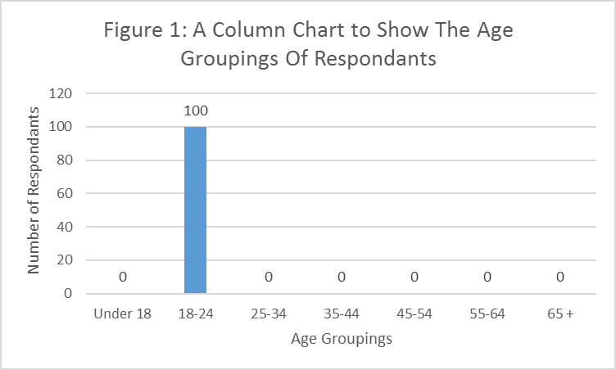

**Figure 2: A Column Chart to Show the Age Groupings of Participants**

Participants were also asked to state their gender (**Figure 3**), which will be used as the variable test in the **T-Tests** later. The results displayed bellow skewed more towards females, with 57% of participants stating they were female, and 43% of respondents stating they were male.

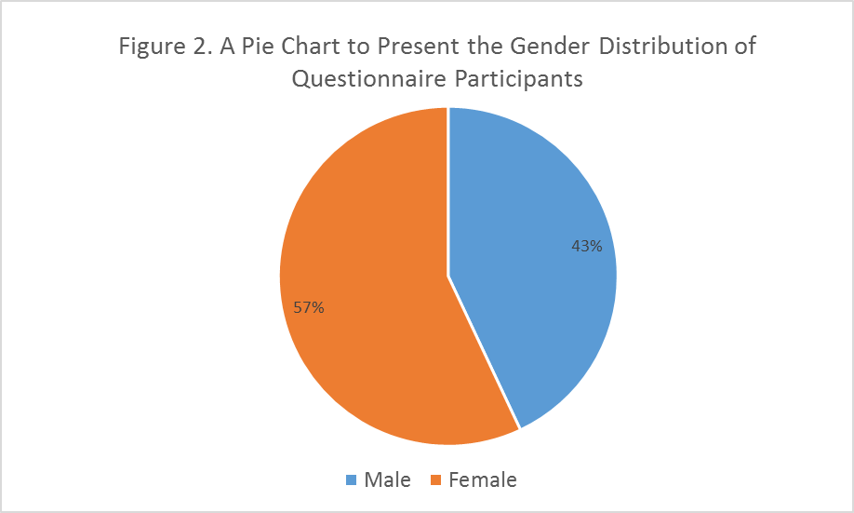

**Figure 3: A Pie Chart to Present the Gender Distribution of Questionnaire Participants**

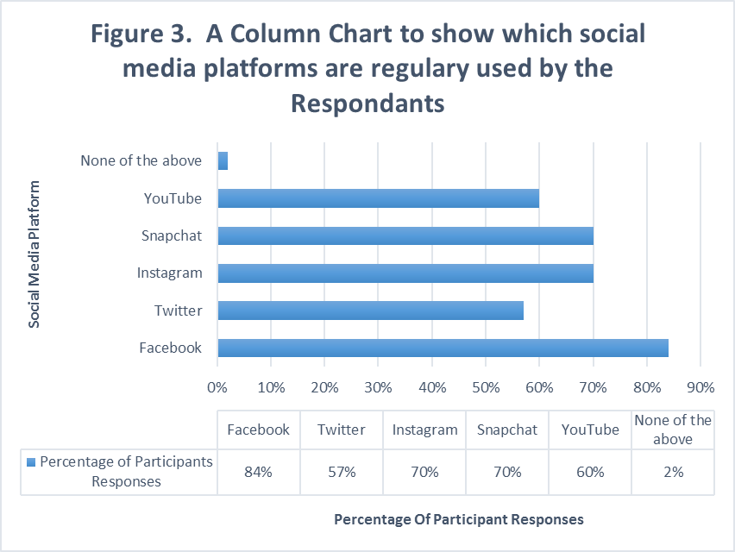

**Figure 4: A Column Chart to Show Which Social Media Platforms Are Regularly Used By Participants**

The participants to the questionnaire were also asked to select out of the pre-constructed list which of the top 5 social media platforms they used on a regular basis. Within **figure 4,** Facebook was found to be the most popular social media site with 84% of respondents selecting this as a regularly used Social Media platform, with Snapchat and Instagram tied in second with both being used by 70% of participants.

**Figure 5** presents the results to a Likert scale which was based on the extent to which participants agreed/disagreed that friends and peers' opinions on products are seriously taken into consideration on social media. 32% of participants felt they “somewhat agreed” that peers and friend’s opinions are taken into consideration on Social Media. “Agree” was the second most popular answer with 22%, and “Strongly Agree” was the third most common answer with 18%. Such results therefore show that there is a generally positive view on eWoM (Electronic Word of Mouth) on Social Media.

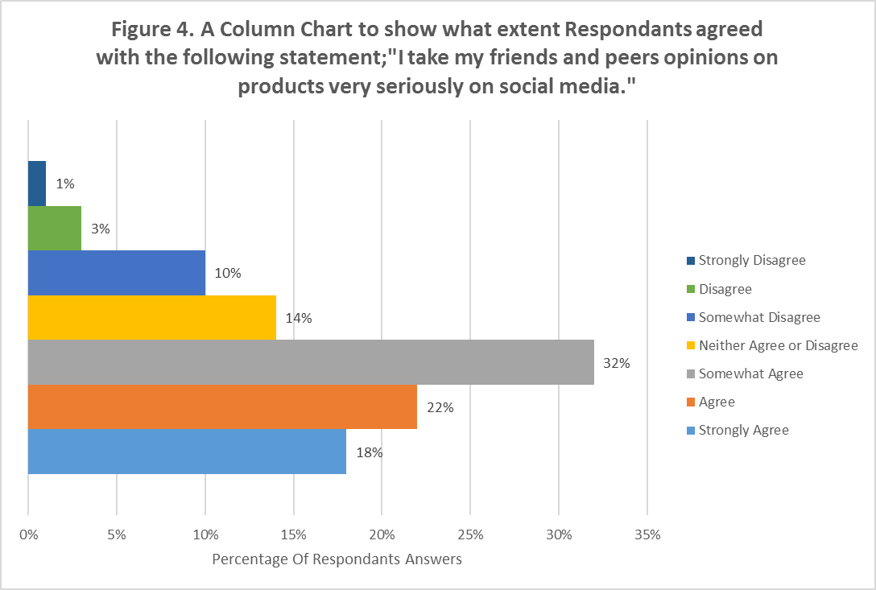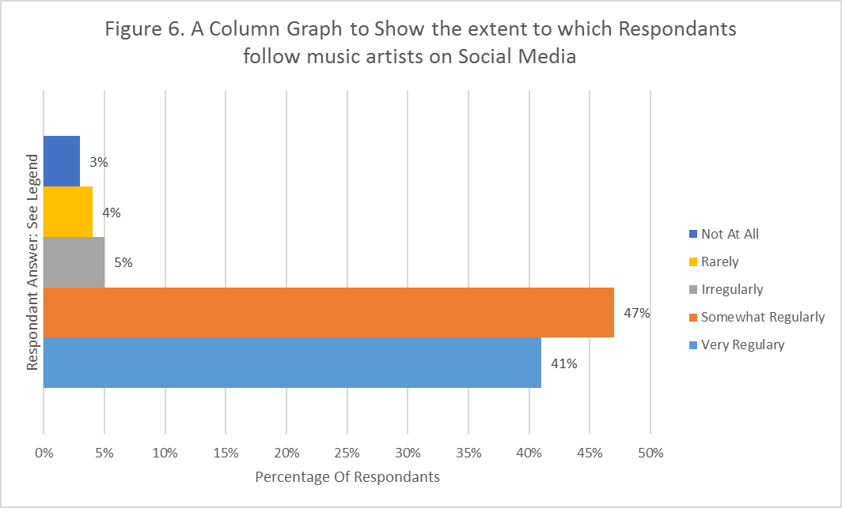

**Figure 5: A Column Chart To Show What Extent Participants Agreed With The Following Statement; "I Take My Friends And Peers Opinions On Products Very Seriously On Social Media."**

**Figure 6** presents feelings participants had to the idea that after seeing information about products shared by social media, they were likely to purchase the product. It was found within the results that they most popular answer was “Somewhat Agree” with 35% of respondents stating this opinion, with “Agree” being the second most common answer with 30%. This therefore suggests that the results and majority opinions shift towards respondents being more positively receptive to purchasing products on the recommendation of friends/peers.

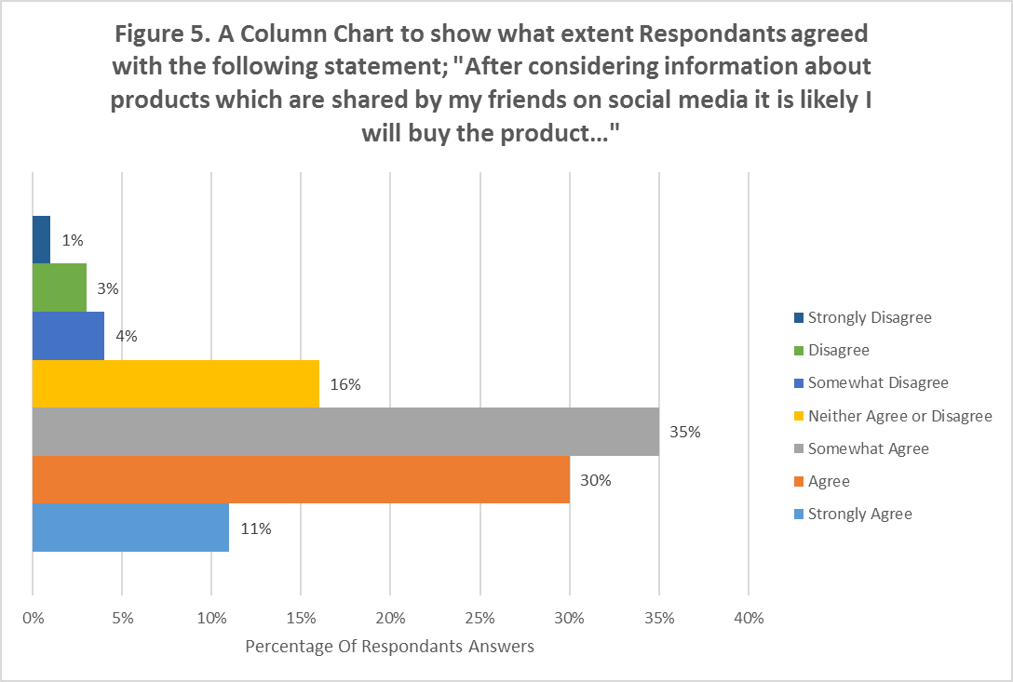

**Figure 6: A Column Chart to Show What Extent Participants Agreed With the Following Statement; “After Considering Information about Products Which Are Shared By My Friends on Social Media It Is Likely I Will Buy the Product..."**

Within **Figure 7**, a question was asked to gage the awareness of respondents to celebrities such as musicians on social media platforms. The results as seen above show that participants were in fact actively following music artists on social media. 47% stated they somewhat regularly followed musicians on social media, with 41% stating they followed music artists very regularly. On the other hand, 5% irregularly followed artists with 4% rarely following them and 3% not following them at all.



**Figure 7: A Column Graph to Show the Extent to Which Participants Follow Music Artists on Social Media**

After asking participants whether they actively followed music artists on social media, the next question (**Presented in figure 8**), asked participants whether artists communicating with fans on social media is more likely to encourage purchasing of their product offering. By assessing the graph, there is a clear visual trend with 66% of respondents stated that “Yes” it did make it more likely, and 18% stated that “No” it didn’t make it more likely, with 16% being unsure of whether it did or didn’t make a purchase more likely.

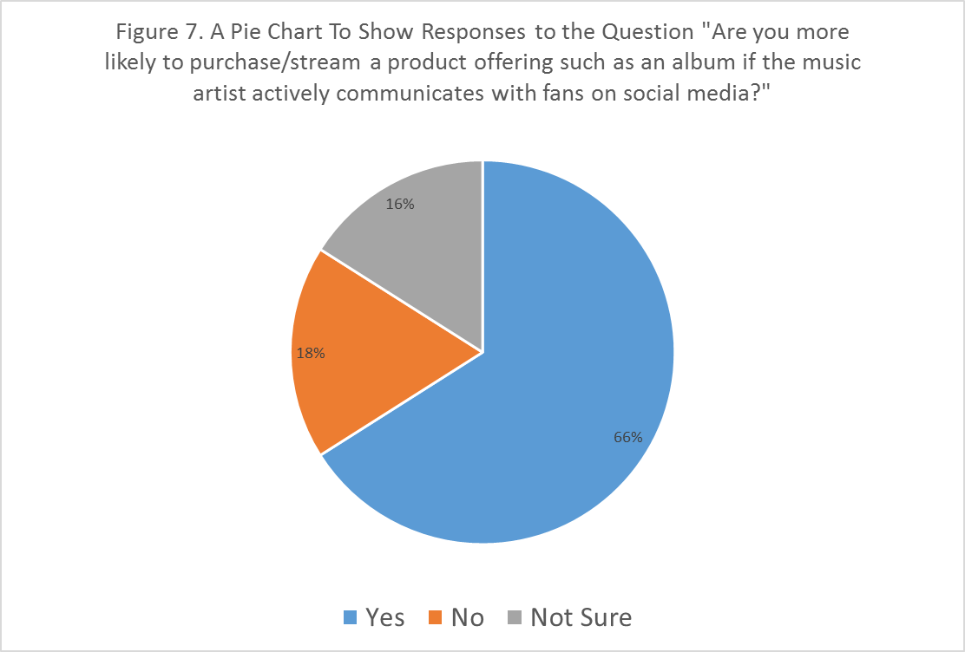

**Figure 8: A Pie Chart to Show Responses to the Question "Are You Likelier To Purchase/Stream a Product Offering Such As an Album If the Music Artist Actively Communicates With Fans on Social Media?"**

**Figure 9** depicts results into question 8 of the questionnaire, which was constructed to see how interactivity in SMM impacts perceived value in the eyes of consumers. Within the column chart above, there is a clear weighting towards interactivity adding value to the product offering. The most common answer within this question was “It adds some value” with 38%, with the second most common being “It adds a lot of value” with 23% and “Unsure of its Value” weighted at 21%.

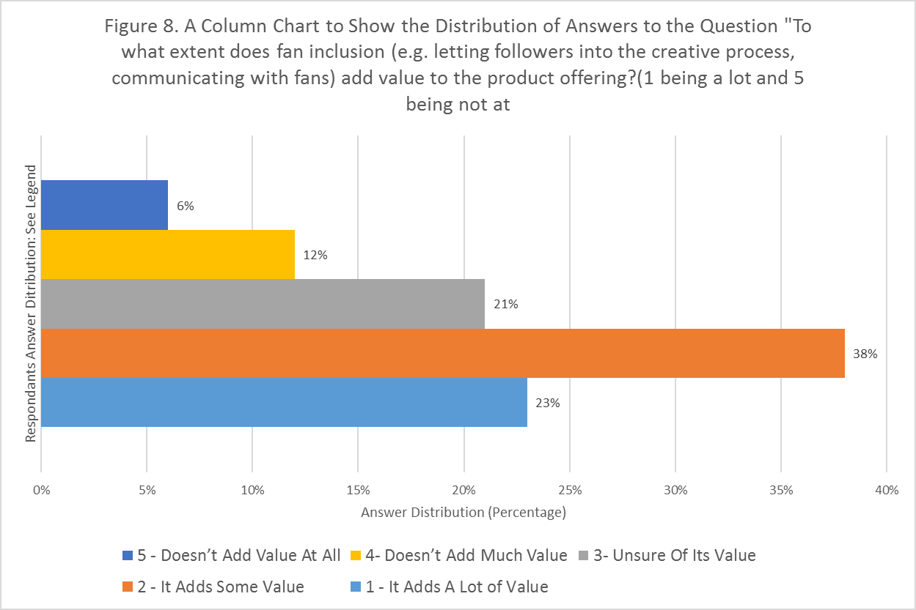

**Figure 9: A Column Chart to Show the Distribution of Answers to the Question "To What Extent Does Fan Inclusion (e.g. Letting Followers into the Creative Process, Communicating with Fans) Add Value to the Product Offering? (1 Being a Lot and 5 Being Not At All)**

**Figure 10** displays the results to a question enquiring which type of SMM communication method is most valued by participants. The most popular answer was the traditional “Status Update” with 37% of respondents selecting this answer as the most valued communication method by music artists. The second most popular answers were multimedia posts and ‘stories’ based posts which had 26% of participants stating it was the most valuable. This therefore shows the most traditional SMM format of text-based status updates are still the most valued form of communication, but multimedia posts and the more recently introduced stories format both hold a relatively high regard in participants’ personal opinions.

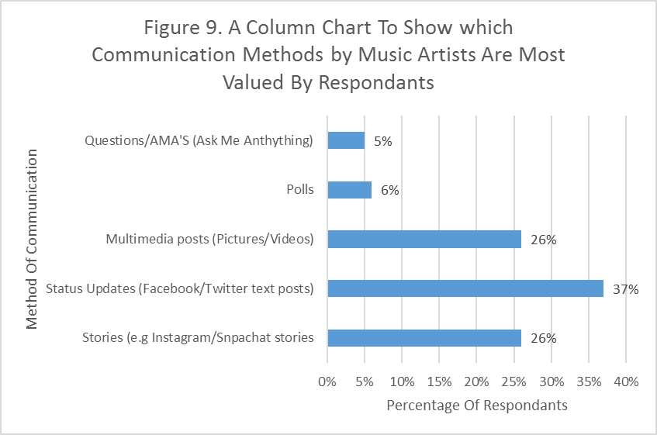

**Figure 10: A Column Chart to Show Which Communication Methods by Music Artists Are Most Valued By Respondents**

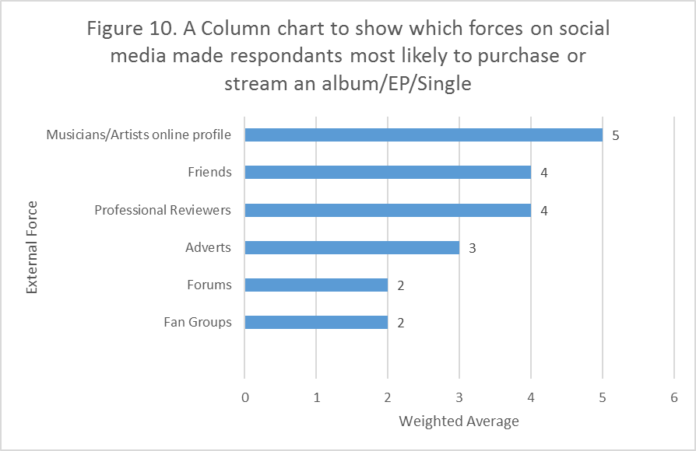

**Figure 11: A Column Chart to Show Which Forces on Social Media Made Participants Most Likely To Purchase or Stream an Album/EP/Single.**

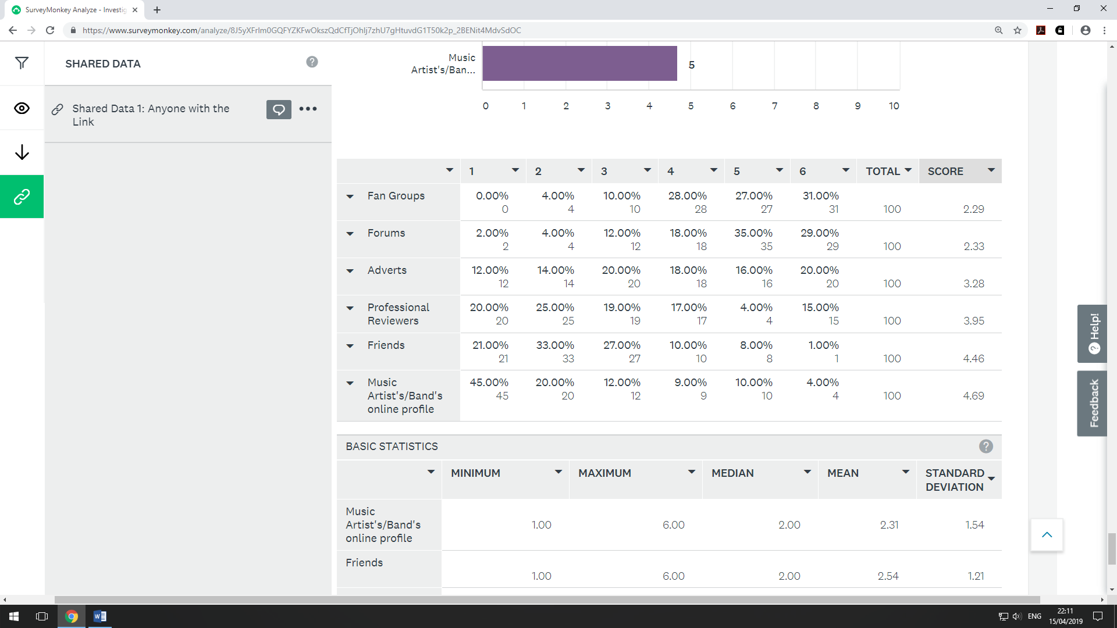

**Figure 12: A Table to show the distribution of rankings of the SMM forces displayed in Figure 10.**

Within **figures 11 and 12**, both displayed above, the results for question 10 are displayed. Question 10 was a ranking based question which asked participants to rank the forces from the force most likely to influence a consumer to purchase/ stream an album/EP/single to the least influential. The highest score within **figure 11 and 12** was therefore the most valuable based on the average ranking of the force by all participants. With a weighted average score of 4.69, artist’s social media profiles were the most influential force on influencing buyer behaviour with figure 11 showing that 45% of participants ranked it 1st within the question. This was followed closely by friends which scored a 4.46 weighted average score with 21% ranking it 1st and 33% ranking it 2nd most valuable.

## 4.3 Data Comparison (Grouped Bar Charts)

Within this section grouped Bar Charts will be used to present data based on categorical groups, or more specifically based on a previous answer to a question within the questionnaire. By comparing results to one questionnaire answer with another, trends can be determined and patterns can be identified and allow for differences to be compared visually in a descriptive analytical manner (Hair et al., 2015). This therefore presents how questions are related and provides a more detailed understanding of the participant’s behaviour and attitudes to towards the subject and sub-topics covered in this research paper.

### 4.3.1 Grouped Bar Chart 1- Artist communication value and method of communication (Figure 13)

The first grouped bar chart within this section concerns a cross examination of the results of both question 7 (***See figure 8***) and question 9 (***See figure 10***).As seen previously in **figure 8**, participants had 3 potential answers to choose from (*Yes, No & Not sure*), therefore placing participants in one of these groups. Each group’s results for question 9 (**figure 10**) were compared within the grouped bar chart seen below. One notable trend is that those participants who were in the “Yes” group seemed to value the “stories” communication method more than the other two control groups with 33% of participants in the “Yes” group stating stories as the most valued communication method, compared with only 11% of the “No” group and 12.5% of the “Not Sure” group.

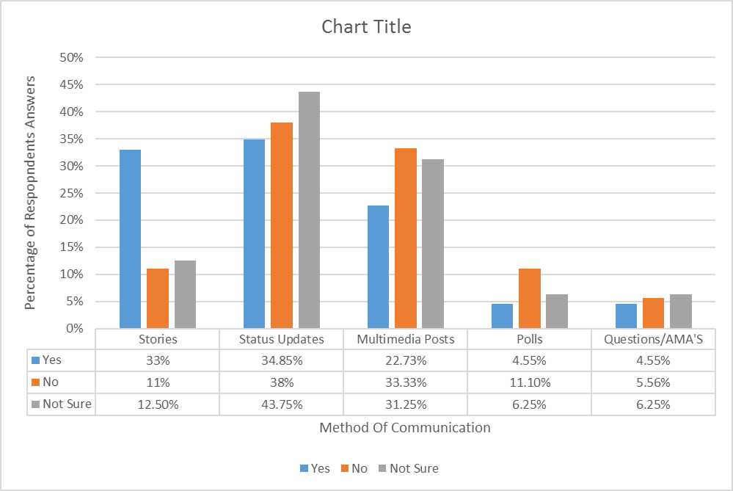

**Figure 13: A Grouped Bar Chart to Show the Answer Distribution of Respondents Most Valued Communication Methods Based on Their Response to Question 7 (Figure 7)**

### 4.3.2 Grouped Bar Chart 2- Gender and artist communication (Figure 14)

This grouped bar chart displays the gender distribution of the groupings identified within question 7 (***See figure 8)***. As seen below 72.09% of male and 61.40% of Female participants stated “Yes” to the idea that they would be more likely to Purchase/Stream a Product Offering Such As an Album If the Music Artist Actively Communicates with Fans on Social Media, this therefore shows that proportionally, male participants were more likely to purchase a product offering if artists actively communicate with fans. However Male participants were proportionately more likely to disagree with the sentiment and state “No” within question 7 than females with 20.93% of males stating no, and 15.79% of females selecting this answer. One notable portion of data however is the difference between the male and female participants on the “Not Sure” answer. 6.98% of Male participants selected this answer, whereas 22.81% of females selected this specific answer, showing that Female participants may exhibit more of an agnostic attitude to question 7, and therefore to the idea that artist communication would make them more likely to purchase a product.

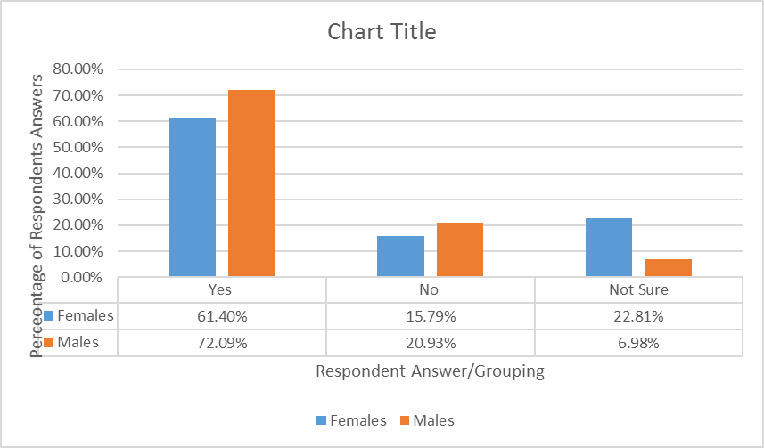

**Figure 14: A Grouped Bar Chart to Show Gender Differences within Participant Valuation of Artist Communication on their purchase decisions**

## 4.4 Statistical Survey Analysis: T-Tests

T-Tests are one method that can be used to aid presentation of inferential statistics. Their purpose is to find whether there is a notable difference between the means of two test groups using an independent variable such as gender/age/test group etc., and a dependant variable such as the results to a question within the questionnaire (Seigle, 2015). For the purpose of this T-Test the independent variable will be gender as it is a clear variable within the questionnaire and can be used to see whether the mean is statistically similar or different. Due to the samples being different sizes (57 females & 43 males) as seen in **figure 3,** a Welch’s T-test will be implemented, which is an adapted version of the standard t-test suited for situations where sample sizes and variances that are unequal between groups (Delacre, Lakens & Leys, 2018).

### 4.4.1 T-Test 1: Question 4 analysis

Question 4 was the first to be statistically tested with a T-test. The question, as described in **figure 4**, was a 7-point Likert scale asking participants to what extent they take their friends and peers opinions on products very seriously on social media. Displayed below are **Figures 15 and 16**, which display the answer for this question when split by gender.

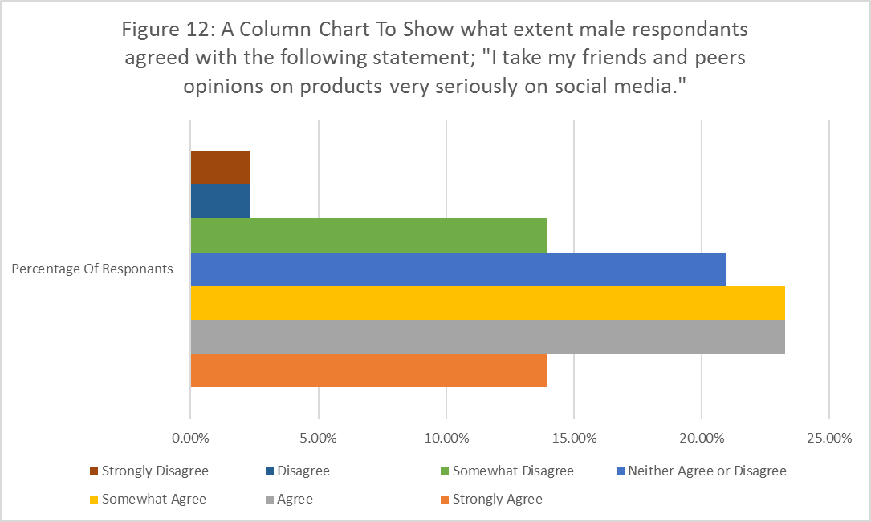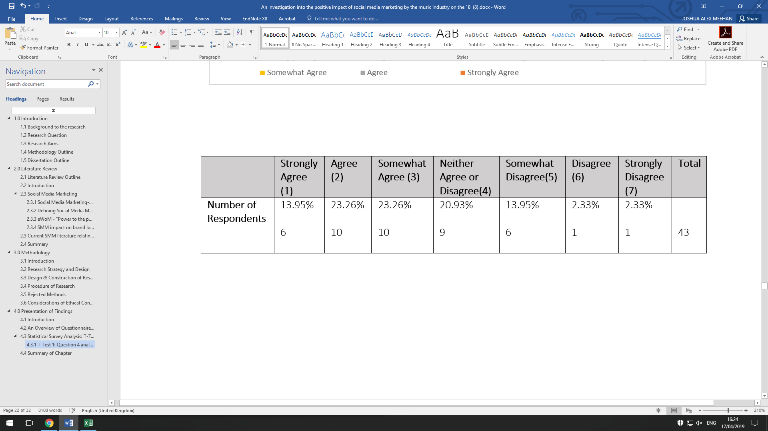

Percentage of Respondent Results

**Figure 15: A Column Chart to Show What Extent Male Participants Agreed with the Following Statement; “I take my friends and peers opinions on social media very seriously on social media.”**



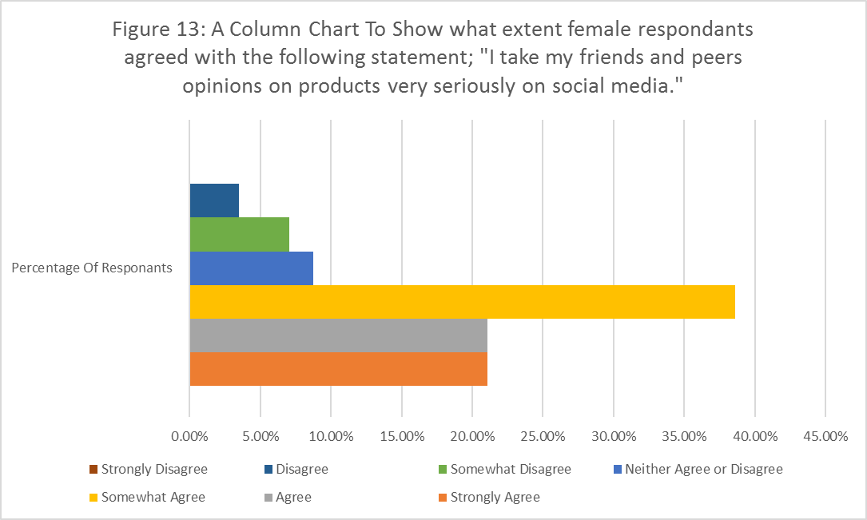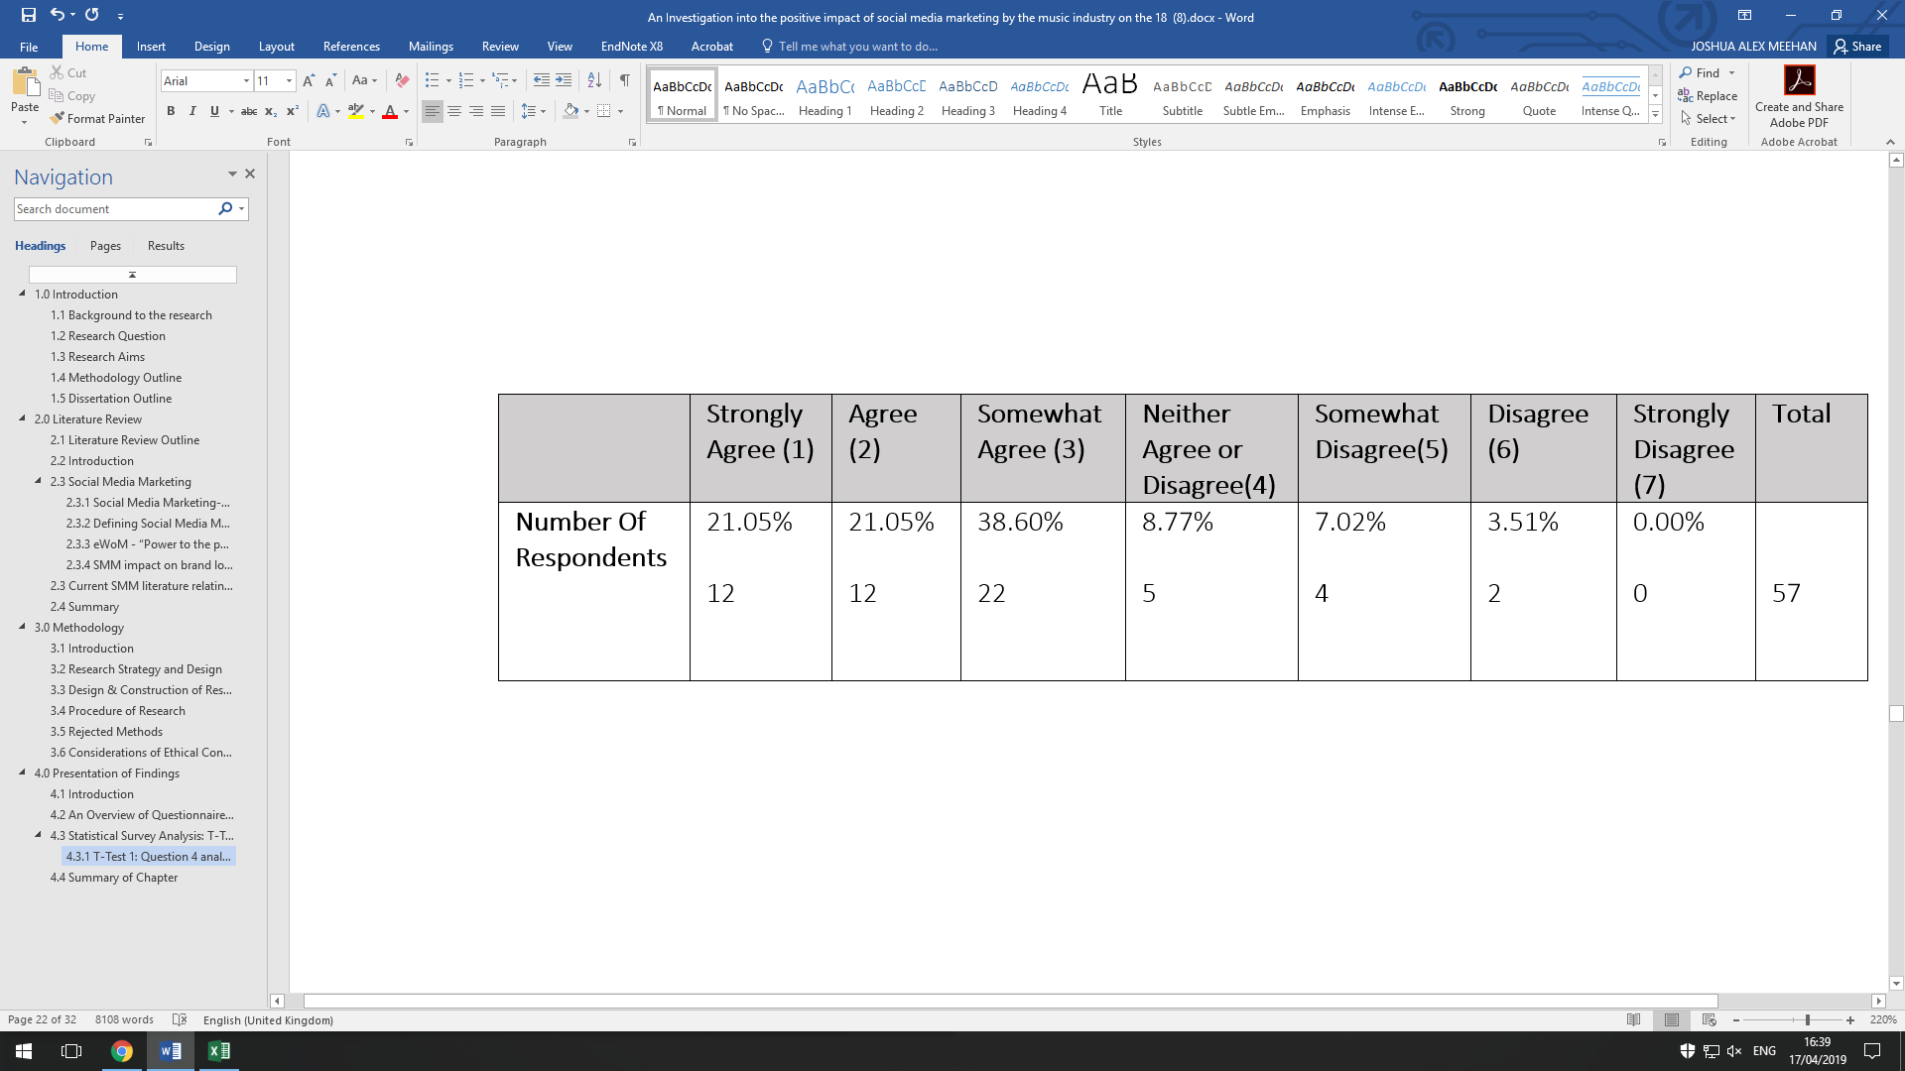

Percentage of Respondent Results

**Figure 16: A Column Chart to Show What Extent Female Participants Agreed with the Following Statement; “I take my friends and peers opinions on social media very seriously on social media.”**

Using Microsoft Excel, a T-Test was constructed based on the data gathered for both variable groups (Male and Female) presented in figures **15 and 16 .** As the data has a null hypothesis, the hypothesised mean difference was set at zero. From this data the P value was calculated at 0.1252, which according to Frost (2018), is statistically insignificant as P= >0.05, therefore meaning that evidence against the null hypothesis is not strong enough. The results of this test therefore show that gender has an insignificant effect on the outcome of results of this specific question.

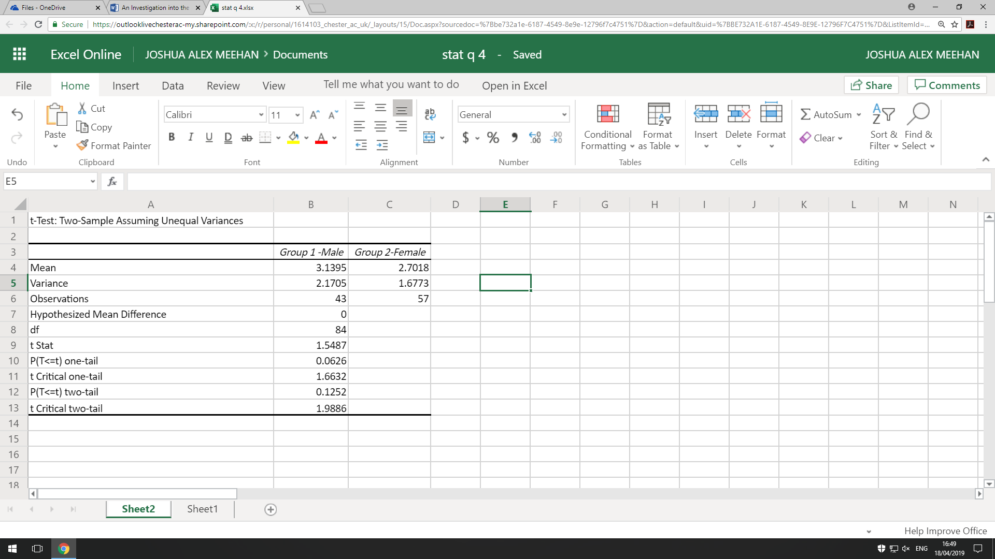

**Figure 17: A T-Test to show the statistical significance of the mean difference of Question 4**

### 4.4.2 T-Test 2: Analysis of Question 5

The second T-Test within this section will be focused on question 5, which was covered within **figure 6.** The question was a Likert scale question on which participants were asked how much they agreed with the following statement; “After considering information about products which are shared by my friends on social media it is likely I will buy the product.” Below **in figures 18 and 19**, the answers to question 5 when split by gender.

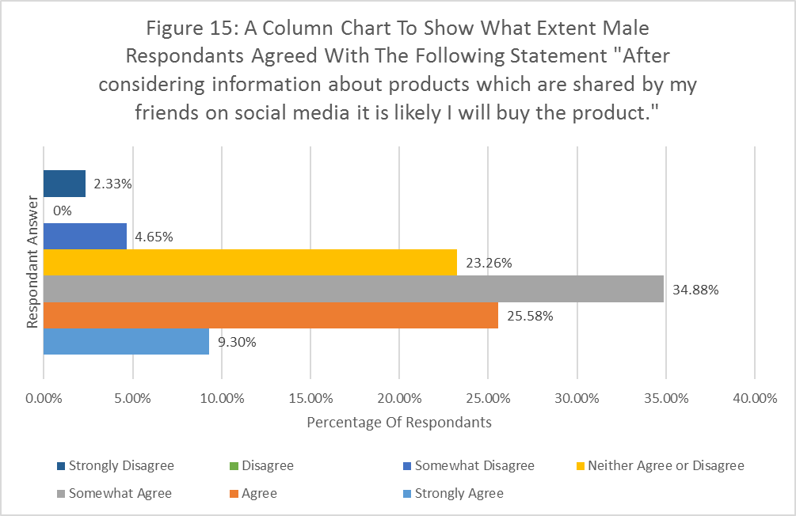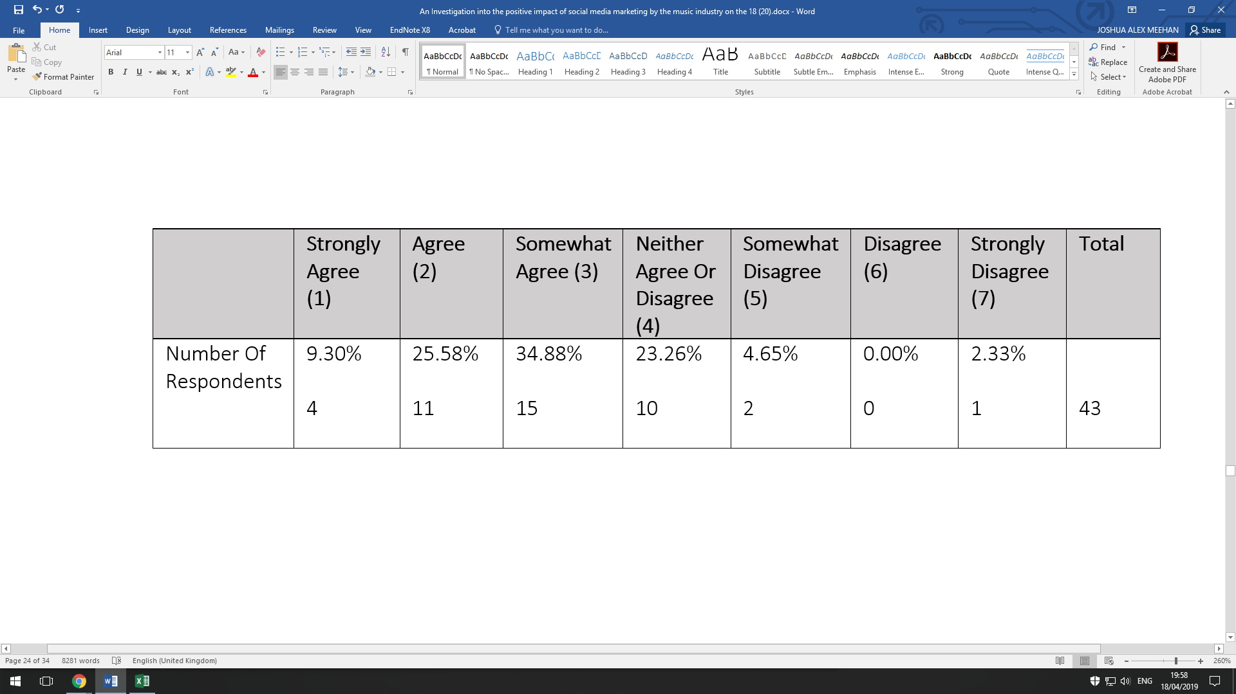

Percentage of Respondents

**Figure 18: A Column Chart to Show What Extent Male Participants Agreed with the Following Statement; “After considering information about products which are shared by my friends on social media it is likely I will buy the product.”**

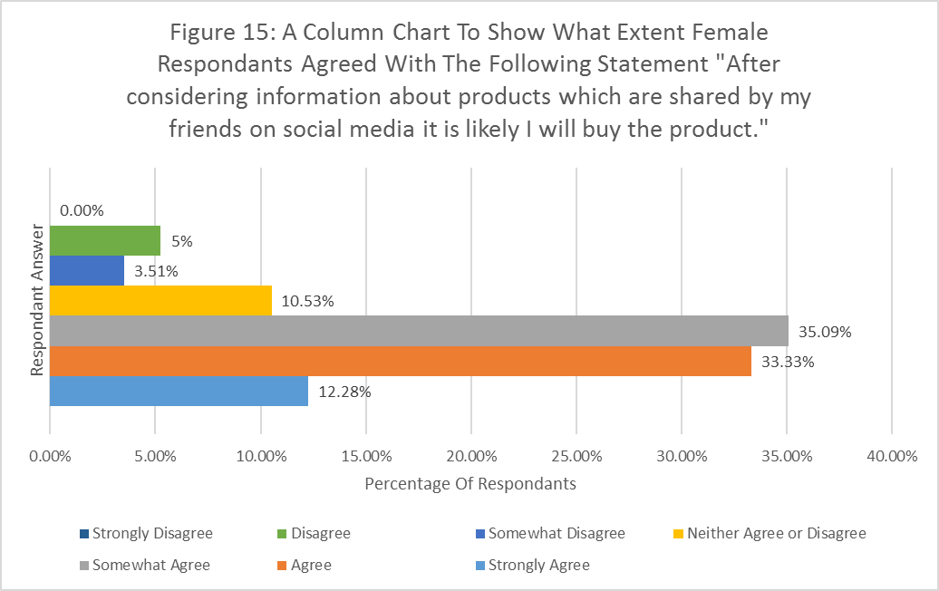

Percentage of Respondents

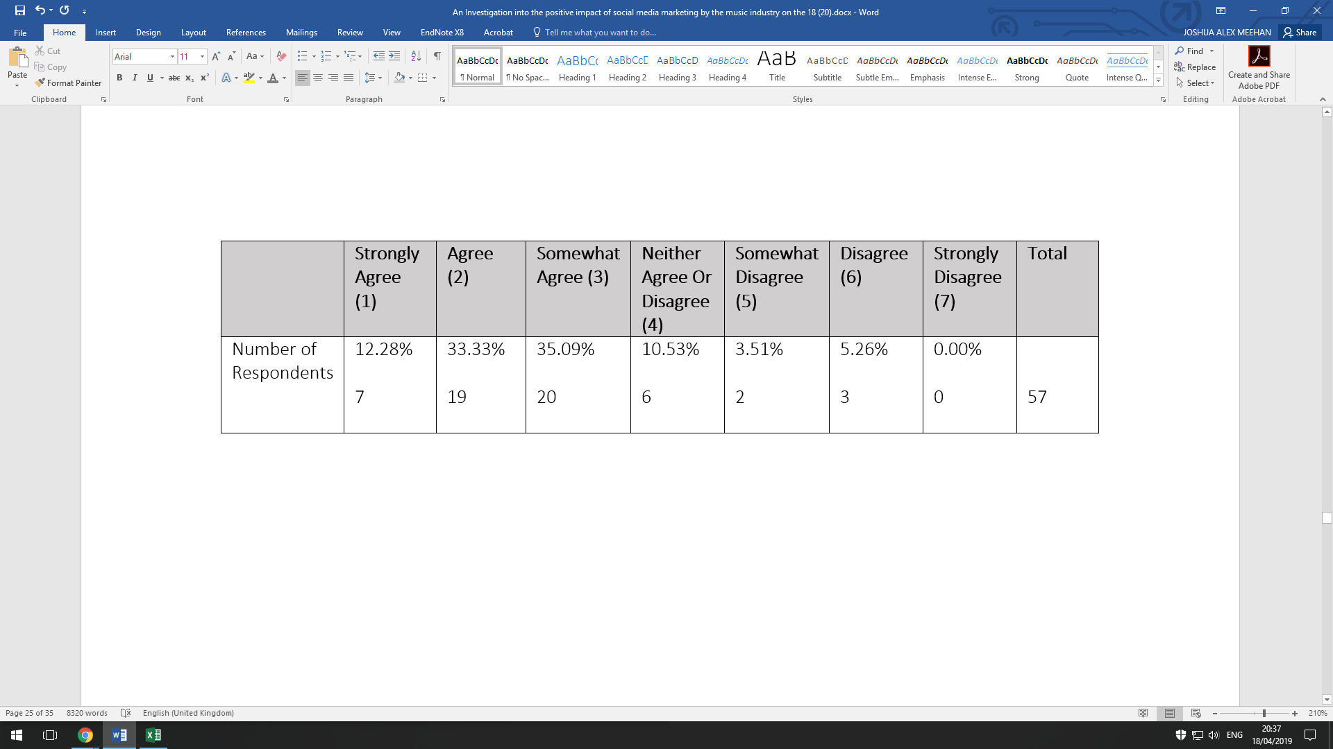

**Figure 19: A Column Chart to Show What Extent Female Participants Agreed with the Following Statement; “After considering information about products which are shared by my friends on social media it is likely I will buy the product.”**

The same method used within the previous Test was applied to this T-Test also. Using Microsoft Excel, the two tail P value was calculated at 0.3674. As P=>0.05 it is therefore statistically insignificant according to Frost (2018). As within the previous T-Test, this states that evidence against the null hypothesis is not significant, meaning that gender has a statistically insignificant role in the outcome of results.

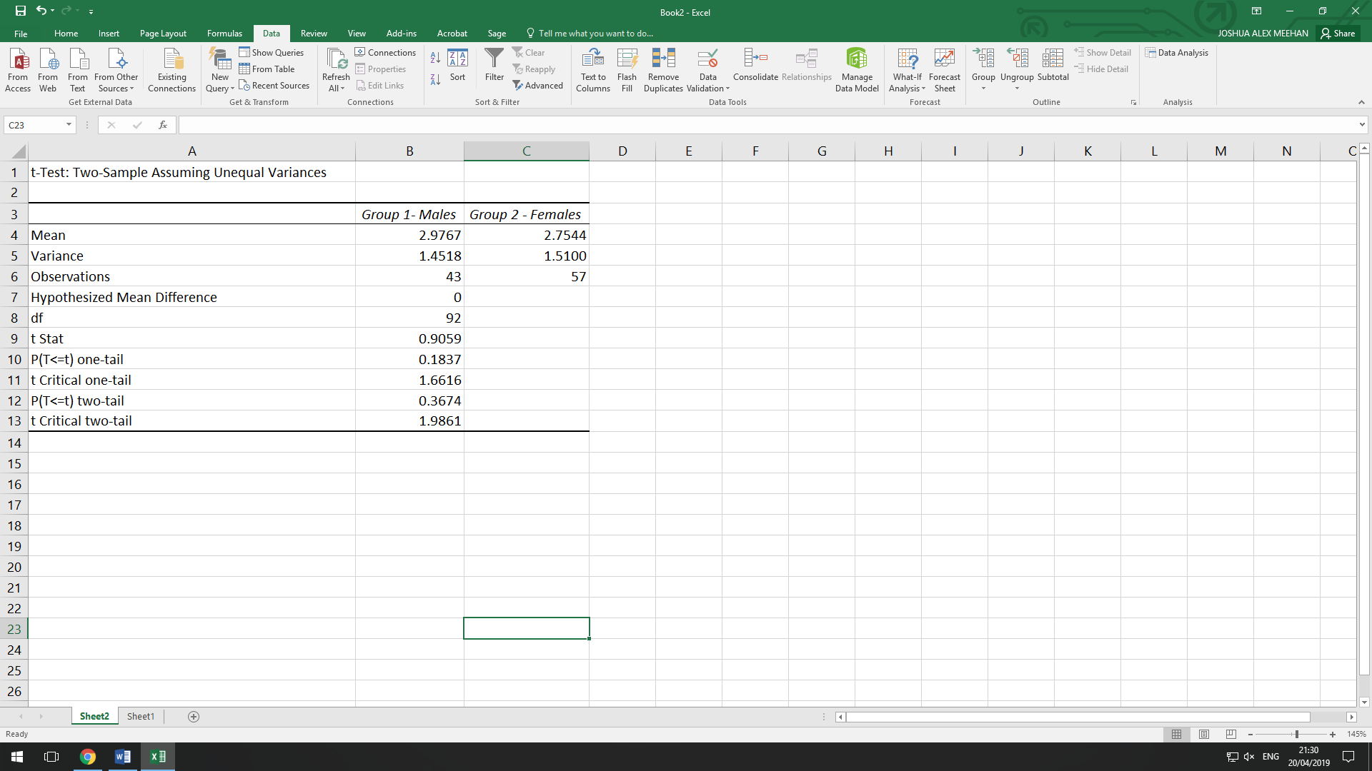

**Figure 20: A T-Test to show the statistical significance of the mean difference of Question 5**

## 4.4 Summary of Chapter

Within this chapter the researcher has outlined multiple data analysis and presentation methods constructed on Microsoft Excel such as descriptive analysis in the forms of grouped bar charts and graphs to present the data of each questionnaire question as well as inferential statistics in the form of Welches T-Tests to test for statistical significance within results. The findings disclosed within this chapter will now be applied to literature and theories within **chapter 2** in the following **chapter 5**, the analysis of findings.

# 5. Analysis of Findings

## 5.1 Introduction

Within this chapter, analysis of the findings that are presented within **Chapter 4** will be linked with the research objectives that were disclosed within **Chapter 1,** with each research objective given a section on which it can be analysed. The results and therefore key knowledge discovered within this research shall then be linked and added to the literature and theory outlined within **Chapter 2.** The chapter will first both analyse general trends and attitudes within the research before delving into the statistical and comparative data displayed previously in **Chapter 4**.

## 5.2 Impact of eWoM on Buying Behaviour (Research Objective 2)

### 5.2.1 eWoM General Trends

Presented within **Figure 5,** a Likert scale question that was based on research instruments used by Erkan & Evans (2016), presented data based on participants level of agreement to the sentiment that they take friends and peers opinions on products very seriously on social media. 32% of participants stated that they “Somewhat Agreed” with the statement, with 22% “Agreeing” and 18% “Strongly Agreeing”. This therefore supports the notion of eWoM being a positive and influential force amongst consumers. This therefore fitted into the narrative within Erkan & Evans (2016), which stated that potential purchase intentions depend on user’s behaviour towards eWoM. As found within this question and its results, the participants of this study have a positive attitude towards eWoM on social media with a total of 72% agreeing with the question displayed in **Figure 5** to at least some degree.

As seen within **Figure 6,** a Likert scale question also derived from Erkan & Evans (2016), 35% of participants of the questionnaire found that they “Somewhat Agreed” with the notion that after considering product information shared by friends, they would likely buy a product. This was followed by 30% of participants stating they “Agreed” with the notion. This therefore showed a positive inclination of consumers towards purchasing behaviour when consumers view eWoM in a positive light as discussed by Erkan & Evans (2016).

### 5.2.2 eWoM: T-Test Analysis

Within Chapter 4, statistical T-Tests were carried out in order to test whether differences in mean within measurable control groups were statistically significant. The control groups that were used within such T-tests, were gender, due to the fact such a measure was not included within notable studies within the literature field by Erkan & Evans (2016) and Kunja (2018). Within chapter **4.4.1** and **4.4.2** a Welches T-Test was conducted. The results as disclosed in both sections were found to be statistically insignificant as the P values calculated and displayed in the aforementioned sections were P=>0.05. Therefore, even though the distributions of answers clearly differed when the control groups were viewed graphically, when they were analysed and viewed in a statistical manner, they were found to be insignificant. This therefore adds a detail to the literature that was not covered by the aforementioned studies by Erkan & Evans (2016) and Kunja (2018). It shows that from this researcher's study, that gender does not play a significant role in the personal opinions of eWoM by consumers.

### 5.2.3 Forces of eWoM

Within **Figure 11,** results were displayed from a question asking participants to rank the most influential forces on social media in terms of incentivising product purchase from most influential to least important. As seen within the graph, music artists own online profile was averagely the highest-ranking answer by participants of the study with a weighted average score of 4.69, followed by friends/peers with a weighted average score of 4.46. Although the scores are close in terms of averages, music artists were ranked as the most valuable by 45% of participants, with friends/peers ranked first by 21% of participants. This therefore argues the statement by Tsao & Hsieah (2015) that third party information platforms are viewed as more reliable and credible than the first party platform. Such a conclusion therefore fits more into the literary narrative provided by Lee & Youn (2009) when viewing the data as weighted averages they stated that posts on corporate platforms and third-party platforms were perceived as the same in relation to purchasing intentions and judgement/perception of products. The studies highlighted in this section however were not directed at the music industry, suggesting that the relationship between consumers and music artists may in fact inhibit a different behaviour pattern to those between consumers and traditional brands.

**Figure 11** also found that fan groups ranked as the least valuable/influential force of eWoM on consumers according to the data provided by the research questionnaire with a weighted average of 2.29 and 31% of participants placing it as the least influential in their personal rankings. This therefore opposes the sentiment Li-Chun et al. (2016), who stated that fan groups/pages were an effective force at providing positive eWoM and Kunja (2018), who echoed such an account by stating that fan pages increased value co-creation and buying intention. According to the data found within this study, such findings are not the case as the researcher of this paper found that such a method of eWoM was considered the least valued by consumers.

## 5.3 Brand Loyalty and the Degree of Participation on Social Media (Research Objective 3)

Within **Figure 7**, participants of the questionnaire were asked to state the extent to which they follow music artists on social media. It was found that 47% of participants “Somewhat Regularly” followed celebrities on Social Media, and 41% were “Very Regularly”. This question was placed in the questionnaire as a measurement to test Ismail (2016) on the idea that followers of pages on social media tend to be more loyal and committed to a brand, and therefore more likely to buy their product. The results within **Figure 7** therefore show that the majority of participants are active followers of music artists on social media.

As displayed within **Figure 8**, it was clear that artist communication was an important factor amongst participants of the research questionnaire. With 66% of participants stating “Yes” to the idea that artists communicating and participating with fans on social media makes it more likely for them to purchase their product offering. This therefore reaffirms the user motivations stated by Salo et al. (2013) which state that participation in user created content and a two-way interaction between groups such as artists and fans are key motivators for consumers following music artists on social media. The results also back up the conclusions drawn by Ismail (2016), with a majority of participants within **Figures 7 and 8** stating they are active followers and more likely to purchase a product if artists communicate on Social Media.

**Figure 9** presented the results for a question asking participants to rank on a scale the extent they believed fan inclusion adds value to a product. 38% of participants stated that it “adds some value” and 23% stated it “adds a lot of value”. This therefore meant that 61% of participants perceived fan inclusion as a valuable force on social media for artists to exert. When compared with conclusions drawn by Yadav (2018) about social media marketing adding value through offering consumers a voice to engage in communication with brands, the conclusions drawn from this question show literary validity as a majority of respondents stating fan inclusion is an effective way of adding value to a product. The concept of fan inclusion adding value can also be related to the entertainment factor of interactivity. Yoshida (2018), suggested that entertainment value was created from identification and relations between brands and consumers. Research within this area did however focused only on behavioural brand loyalty, which was a criticism brought up by the researcher of this paper. The research gathered from the research questionnaire within this paper found consequential evidence as echoed previously within **Figure 8**, as 66% of participants agreed that artist communication made it more likely for them to purchase a product. This therefore added literary knowledge and evidence that Brand/Fan interaction can lead to a higher inclination of potential buyer behaviour due to the perceived added value interaction gives to consumers.

## 5.4 Effective Methods of Communication within Social Media Marketing (Research Objective 4)

One area identified as a literary gap within the literature review was the absence of new social media platforms as well as the effectiveness of different forms of communication within social media marketing. Salo (2013) for example only used Facebook and Myspace as examples within their research, which the researcher of this paper criticised due to the lack of potential relevance to ‘new’ social media platforms such as Instagram and Snapchat. As seen with **Figure 4**, Instagram and Snapchat were used by 70% of participants, showing that such platforms should be included within literary discussion of social media marketing. Facebook however was still the most popular medium of social media with 84% of participants using it, which reaffirms the importance of the platform to brands as stated by Greenwood (2018).

Instagram however was noted by Latif & Safiee (2015) as a core platform due to its emphasis on visuals, which strengthened a brands image and brand communication. This can be seen within **Figure 10,** which showed that 26% of participants valued multimedia posts such as pictures and videos with another 26% valuing story based posts, which are both the primary content shared on Instagram. However, 37% of participants actually preferred standard text-based status updates seen on Twitter and Facebook, which therefore shows that although the ‘new’ communication methods such as multimedia posts and stories are important communication methods within the context of social media marketing, consumers still prefer traditional text-based posts.

A grouped bar chart was also used to analyse the link between their personal value of artist communication on potential product purchases and the communication methods on social media that the participants valued the most, which can be seen in **Figure 13.** The results showed 33% of people in the “yes” group for communication increasing the likely hood of product purchasing also chose “Stories” as their preferred method of communication, however 33% of participants within the “no” group selected multimedia posts as their most preferred medium, which suggests that within the context of visual based social media platforms such as Instagram, the selection of the most effective communication platform is key, which contributes further to Latiff & Safiee (2015), findings about Instagram as according to the results of the research instrument, the value of brand communication on Instagram co-depends on the communication method it uses, whether it be stories or multimedia posts. Multimedia posts and story-based posts may be valued in a similar way within Figure 9, but in the context of brand communication and product purchasing, ‘Stories’ can be seen as the more valuable asset for music artists on Instagram.

## 5.5 Summary of Chapter

By combining the academic literature reviewed within chapter 2 with the investigative results presented within chapter 4, this investigation into the positive impact of social media marketing on music artists has drawn some notable findings. The first such conclusion is that social media marketing can impact music artists in a positive way when implemented correctly. This can be seen through the analysis of findings throughout this chapter such as conformation of a positive attitude towards eWoM on social media (See **figures 5 and 6**) reinforcing findings by Erkan & Evans (2016). The different forces of eWoM were also tested as seen within **figure 11**, with this study finding that musicians own social media pages were ranked as the most influential, which challenges Tsao & Hsieah (2015) and their idea that third party information is viewed as more credible compared to first party information by organisations. The ideas put forth by Ismail (2016) were also found to have been reinforced by the research paper as seen within **figures 7 and 8** which present that followers on social media tend to be more brand loyal and more likely to purchase because of brand communication. However, there are still limitations within this research paper that can be addressed as well as areas of further research based upon the findings within this investigation, such topics will be displayed within chapter 6.

# 6.0 Conclusions

## 6.1 Introduction

The overall objective of this research paper was to investigate the potential positive impact that social media and social media users in the aged 18-24 can have on music artists. The research therefore adopted existing literature and theories of social media marketing as well as its sub topics of eWoM, communication and brand loyalty which was discussed in chapter 2 and was applied to the findings within chapters 4 and 5 to analyse the level to which social media can act as a positive force for music artists.

## 6.2 Critical Evaluation of Research Methodology

The approach that was chosen for this research paper was to adopt a similar methodological approach to Erkan & Evans (2016). This was therefore a quantitative methodology which implemented a questionnaire as a research instrument. The questionnaire was a closed answer style questionnaire. There was however an issue with such a method as closed ended questions have the chance of forcing participants to give answers they may not necessarily fit into as well as a potential for investigator effects as the question and its corresponding answers may hint to participants what answer the investigator is looking for (Hyman & Sierra, 2016). A mixed method approach may have therefore been more suited to this research topic as such a research design it allows for collection of more comprehensive data and provide a broader perspective based on both observations and statistical analysis (CIRT, 2019). A mixed methods approach would have also allowed for the implementation of ‘spontaneous questions’ which are open ended and could be used to explore participant’s attitudes as well as user awareness (Brace, 2013). This would therefore have allowed for a more accurate measurement of personal attitudes and behaviour of participants on social media marketing.

## Review of Research Objectives

The investigation outlined within this paper has been successful in answering the research objectives outlined within chapter 1. Objective 1, a critical evaluation of existing literature was met within the literature review of chapter 2 of this research paper. Within it literature on the overarching theme of social media marketing as well as key subtopics such as electronic word of mouth and brand loyalty were analysed critically as were journal articles and other literature more heavily focused on the music industry theme.

Objective 2 concerned the extent to which electronic word of mouth can influence users of social media within the context of music artists and their product offerings. This objective was reviewed extensively within chapter 4 as well as chapters’ 5.2.1-5.2.3. The findings concluded that participants had a positive attitude to electronic word of mouth and such a force was able to positively incline participants to potentially purchase a product based on word of mouth recommendations. However, within figure 10, it was found that artists own social media pages were perceived as a stronger force for potential purchasing, showing that the artists own ‘brand personality’ is a crucial factor on potential purchases.

Objective 3 was concerned with platform preferences and post participation with music related social media accounts. In terms of platform preferences this was displayed within figure 3, which showed the percentage of participants who actively used each social media page, with Facebook being the most popular platform overall. In terms of participation, that was addressed in figure 6 within chapter 4, where the findings presented that participants did actively follow music artists on social media.

Within objective 4 analysis of how social media can be implemented by musicians to increase brand loyalty and equity was discussed and met within chapter 4 within figures 7, 8, 9 and 10. Which enforced the idea that participants are active followers and social media can be used to increase brand equity and loyalty through active communication with fans through different communication mediums (primarily status updates and stories) as they are seen as the most influential force to convince participants to stream or purchase a product such as a single/EP/album.

## 6.4 Investigation Limitations

During the process of the investigation some limitations were found that are of note. Within the data collection method of online anonymous surveys there are potential discrepancies that can arise such as the potential that participants may have lied about their age in order to complete the survey, therefore potentially decreasing the validity of this research. With the anonymous online survey, it is also possible participants filled out multiple surveys, whether that be intentional or unintentional which could also impact the credibility and validity of the research. Although the examination of 18-25-year olds was chosen due to their high usage of social media, other age demographics could also have been considered within the research to gain a more representative understanding of social media marketing upon the wider online population.

## Future Research Opportunities

Within the area of future research, there are opportunities that present themselves. As mentioned within chapter 6.4, other age demographics could be explored to find out whether such control groups respond differently to social media marketing than the 18-25 demographic. Such exploration of other age demographics could provide knowledge on how to more dynamically target different demographics of users rather than just the aforementioned 18-25 demographic. Further research could also benefit from researching differences in attitudes by the individual social media platforms as attitudes on eWoM and interactivity could be impacted by the platform such forces are exerted on.

# 7.0 References

Ahmed, Q. M., Raziq, M. M., & Ahmed, S. (2018). The role of social media marketing and brand consciousness in building brand loyalty. Global Management Journal for Academic & Corporate Studies, 8(1), 154-165. Retrieved from https://search.proquest.com/docview/2131793734?accountid=14620

Alves, H., Fernandes, C., & Raposo, M. (2016). Social Media Marketing: A Literature Review and Implications. *Psychology & Marketing,33*(12), 1029-1038. doi:10.1002/mar.20936

Ashley, C., & Tuten, T. (2014). Creative Strategies in Social Media Marketing: An Exploratory Study of Branded Social Content and Consumer Engagement. *Psychology & Marketing,32*(1), 15-27. doi:10.1002/mar.20761

Aslam, S. (2019, January 06). Instagram by the Numbers: Stats, Demographics & Fun Facts. Retrieved from https://www.omnicoreagency.com/instagram-statistics/

Bourreau, M., Doğan, P., & Hong, S. (2015). Making money by giving it for free: Radiohead’s pre-release strategy for In Rainbows. Information Economics and Policy, 32, 77-93.

Chan, N. & Guillet, B. (2011). Investigation of Social Media Marketing: How Does the Hotel Industry in Hong Kong Perform in Marketing on Social Media Websites?, *Journal of Travel & Tourism Marketing*, 28(4), 345-368, DOI: 10.1080/10548408.2011.571571

Chen, C., & Lien, N. (2017). Social media and marketing effectiveness.*Asia Pacific Management Review, 22*(1), 1-1. doi:10.1016/j.apmrv.2017.02.002

Chen, J. (2019, January 24). 7 social media trends to watch in 2019. Retrieved from https://sproutsocial.com/insights/social-media-trends/

Dewan, S., Ramaprasad, J., McGill University, & University of California, I. (2014). social media, traditional media, and music sales. Mis Quarterly, 38(1), 101-121. doi:10.25300/MISQ/2014/38.1.05

Dolan, R., Conduit, J., Fahy, J., & Goodman, S. (2017). Social media: Communication strategies, engagement and future research directions. *International Journal of Wine Business Research,29*(1), 2-19. doi:10.1108/ijwbr-04-2016-0013

Dwivedi, A., Merrilees, B., Miller, D., & Herington, C. (2012). Brand, value and relationship equities and loyalty-intentions in the Australian supermarket industry. Journal of Retailing and Consumer Services, 19(5), 526-536. doi:10.1016/j.jretconser.2012.06.009

Dwivedi, Y.K., Kapoor, K.K. and Chen, H., 2015. Social media marketing and advertising. The Marketing Review, 15(3), pp.289-309.

Erkan, I., & Evans, C. (2016). The influence of eWOM in social media on consumers’ purchase intentions: An extended approach to information adoption. Computers in Human Behavior, 61, 47-55. doi:10.1016/j.chb.2016.03.003

Feehan, B. (2018, June 27). 2018 Social Media Industry Benchmark Report. Retrieved from https://blairfeehan.com/2018/04/02/2018-social-media-industry-benchmark-report/

Felix, R., Rauschnabel, P. and Hinsch, C., 2017. Elements of strategic social media marketing: A holistic framework. Journal of Business Research, 70, pp.118-126. doi:10.1016/j.jbusres.2016.05.001

Godey, B., Manthiou, A., Pederzoli, D., Rokka, J., Aiello, G., Donvito, R., & Singh, R. (2016). Social media marketing efforts of luxury brands: Influence on brand equity and consumer behavior. Journal of Business Research, 69(12), 5833-5841. doi:10.1016/j.jbusres.2016.04.181

Greenwood, W. (2018, June 07). 2018 Social Media Marketing Report Overview. Retrieved from https://browsermedia.agency/blog/social-media-marketing-report-overview/

Ismail, A. (2017). The influence of perceived social media marketing activities on brand loyalty the mediation effect of brand and value consciousness. Asia Pacific Journal of Marketing and Logistics, 29(1), 129-144. doi:10.1108/APJML-10-2015-0154

Kaplan, A. M., & Haenlein, M. (2011). Two hearts in three-quarter time: How to waltz the social media/viral marketing dance. *Business Horizons,54*(3), 253-263. doi:10.1016/j.bushor.2011.01.006

Keegan, B. J., & Rowley, J. (2017). Evaluation and decision making in social media marketing.*Management Decision, 55*(1), 15-31. doi:10.1108/MD-10-2015-0450

Kidane, M. (2019, February 19). 30 Brain-Expanding Social Media Marketing Stats for 2019. Retrieved from https://www.falcon.io/insights-hub/topics/social-media-strategy/2018-social-media-marketing-statistics/

Kunja, S. R., & GVRK, A. (2018). Examining the effect of eWOM on the customer purchase intention through value co-creation (VCC) in social networking sites (SNSs): A study of select facebook fan pages of smartphone brands in india. Management Research Review, doi:10.1108/MRR-04-2017-0128

Latiff, Z. A., & Safiee, N. A. (2015). New Business Set Up for Branding Strategies on Social Media – Instagram. *Procedia Computer Science,72*, 13-23. doi:10.1016/j.procs.2015.12.100

Lee, M., & Youn, S. (2009). Electronic word of mouth (eWOM): How eWOM platforms influence consumer product judgement. International Journal of Advertising, 28(3), 473-499. doi:10.2501/S0265048709200709

Li-Chun, H., Wen-Hai Chih, & Liou, D. (2016). Investigating community members’ eWOM effects in facebook fan page. Industrial Management & Data Systems, 116(5), 978-1004. doi:http://dx.doi.org/10.1108/IMDS-07-2015-0313

Lis, B. (2013). In eWOM we trust: A framework of factors that determine the eWOM credibility. Business & Information Systems Engineering, 5(3), 129-140. doi:10.1007/s12599-013-0261-9

Lua, A. (2019, January 24). 21 Top Social Media Sites to Consider for Your Brand -. Retrieved from https://buffer.com/library/social-media-sites

Mangold, W. G., & Faulds, D. J. (2009). Social media: The new hybrid element of the promotion mix. *Business horizons*, *52*(4), 357-365.

McDaniel, S., & Beger, S. (2016, January 07). Marketing

Morris, J. (2014). Artists as entrepreneurs, fans as workers. Popular Music and Society, 37(3), 273-290. doi:10.1080/03007766.2013.778534

Murdough, C. (2009). Social media measurement: It’s not impossible. *Journal of Interactive Advertising*, *10*(1), 94-99

Nadaraja, R., & Yazdanifard, R. (2013). Social media marketing: advantages and disadvantages. *Social Media Marketing*, 1-10.

Office for National Statistics. (2017). Social networking by age group, 2011 to 2017. Retrieved from https://www.ons.gov.uk/peoplepopulationandcommunity/householdcharacteristics/homeinternetandsocialmediausage/adhocs/007401socialnetworkingbyagegroup2011to2017

Ou, Y., Vries, L. D., Wiesel, T., & Verhoef, P. C. (2013). The Role of Consumer Confidence in Creating Customer Loyalty. Journal of Service Research, 17(3), 339-354. doi:10.1177/1094670513513925

Pasternak, O., Veloutsou, C., & Morgan-Thomas, A. (2017). Self-presentation, privacy and electronic word-of-mouth in social media. Journal of Product & Brand Management, 26(4), 415-428. doi:10.1108/JPBM-04-2016-1150

Salo, J., Lankinen, M., & Mäntymäki, M. (2013). The use of social media for artist marketing: Music industry perspectives and consumer motivations. The International Journal on Media Management, 15(1), 23-41. doi:10.1080/14241277.2012.755682

Sherpa Consumer Purchase Preference Survey: Demographics of customer reasons to follow brands' social accounts. Retrieved from https://www.marketingsherpa.com/article/chart/demographics-why-customer-follow-brands-social-media

Smith, K. (2019). 122 Amazing Social Media Statistics and Facts. Retrieved from https://www.brandwatch.com/blog/amazing-social-media-statistics-and-facts/

Sohn, D. (2014). Coping with information in social media: The effects of network structure and knowledge on perception of information value. *Computers in Human Behavior*, *32*, 145-151.

Statista. (2018). UK: Social media penetration 2018 | Statistic. Retrieved from https://www.statista.com/statistics/507405/uk-active-social-media-and-mobile-social-media-users/

Stelzner, M. (2013). The 2013 social media marketing industry report. *Social Media Examiner*. Retrieved from http://www.socialmediaexaminer.com/SocialMediaMarketingIndustryReport2013.pdf

Taylor, S. A., Celuch, K., & Goodwin, S. (2004). The importance of brand equity to customer loyalty. Journal of Product & Brand Management, 13(4), 217-227. doi:10.1108/10610420410546934

Tiago, Maria Teresa Pinheiro Melo Borges, & Veríssimo, J. M. C. (2014). Digital marketing and social media: Why bother? Business Horizons, 57(6), 703-708. doi:10.1016/j.bushor.2014.07.002

Tsao, W., & Hsieh, M. (2015). eWOM persuasiveness: Do eWOM platforms and product type matter? Electronic Commerce Research, 15(4), 509-541. doi:10.1007/s10660-015-9198-z

VINEREAN, S. (2017). Importance of strategic social media marketing.*Expert Journal of Marketing, 5*(1), 28-35

Vogel, V., Evanschitzky, H., & Ramaseshan, B. (2008). Customer Equity Drivers and Future Sales. Journal of Marketing, 72(6), 98-108. doi:10.1509/jmkg.72.6.98

Warren, M. (2019, February 08). Word of Mouth Marketing in 2019: Effective Strategies Examples. Retrieved from https://www.bigcommerce.co.uk/blog/word-of-mouth-marketing/#what-is-word-of-mouth-marketing

Yadav, M. and Rahman, Z., 2017. Measuring consumer perception of social media marketing activities in e-commerce industry: Scale development & validation. Telematics and Informatics. Forthcoming. doi:10.1016/j.tele.2017.06.001

Yadav, M., & Rahman, Z. (2018). The influence of social media marketing activities on customer loyalty. Benchmarking, 25(9), 3882-3905. doi:http://dx.doi.org/10.1108/BIJ-05-2017-0092

Yoshida, M., Gordon, B. S., Nakazawa, M., Shibuya, S., & Fujiwara, N. (2018). Bridging the gap between social media and behavioral brand loyalty. Electronic Commerce Research and Applications, 28, 208-218. doi:10.1016/j.elerap.2018.02.005

Zote, J. (2019, February 01). 65 Social Media Statistics to Bookmark in 2019. Retrieved from https://sproutsocial.com/insights/social-media-statistics/

Newby, P. T. (2014). Research methods for education (Second ed.). London: Routledge.

Cohen, L., Manion, L., & Morrison, K. (2018;2017;). Research methods in education (Eighth ed.). London: Routledge.

Saunders, M., Thornhill, A., & Lewis, P. (2015). Research methods for business students (Seventh ed.). Harlow: Pearson.

Smith, A., & Anderson, M. (2018, September 19). Social Media Use 2018: Demographics and Statistics. Retrieved from https://www.pewinternet.org/2018/03/01/social-media-use-in-2018/

Newby, P. T. (2014). Research methods for education (Second ed.). London: Routledge.

Jackson, S. L. (2014). Research methods: A modular approach. Australia: Wadsworth.

Bornstein, M. H., Jager, J., & Putnick, D. L. (2013). Sampling in Developmental Science: Situations, Shortcomings, Solutions, and Standards. Developmental review : DR, 33(4), 357-370.

Dudovski, J. (2018). Sampling in Primary Data Collection. Retrieved from https://research-methodology.net/sampling-in-primary-data-collection/

Cook, S. (2016). Advantages of Microsoft Excel. Retrieved from <https://turbofuture.com/computers/Advantages-of-Microsoft-Excel>

Creswell, J. W., Plano Clark, V. L., Gutmann, M. L., & Hanson, W. E. (2003). Advanced mixed methods research designs. Handbook of mixed methods in social and behavioral research, 209-240.

Kayam, O., & Hirsch, T. (2012). Using social media networks to conduct questionnaire based research in social studies case study: Family language policy. Journal of Sociological Research, 3(2), 57-67.

Buchanan, E. A., & Hvizdak, E. E. (2009). Online survey tools: Ethical and methodological concerns of human research ethics committees. Journal of Empirical Research on Human Research Ethics, 4(2), 37-48.

Delacre, M., Lakens, D., & Leys, C. (2017). Why Psychologists Should by Default Use Welchs t-test Instead of Students t-test (in press for the International Review of Social Psychology). doi:10.31219/osf.io/sbp6k

Hair, J. F., Wolfinbarger, M., Money, A. H., Samouel, P., & Page, M. J. (2015). *The essentials of business research methods* (3rd ed.). London: Routledge.

Bernazzani, S. (2018, May 03). The Decline of Organic Facebook Reach & How to Adjust to the Algorithm. Retrieved from <https://blog.hubspot.com/marketing/facebook-organic-reach-declining>

Brace, I., & Market Research Society. (2013). Questionnaire design: How to plan, structure and write survey material for effective market research (3rd ed.). London: KoganPage

Hyman, M., & Sierra, J. (2016). Open- versus close-ended survey questions. *NMSU Business Outlook, 14*(2). Retrieved from https://www.researchgate.net/publication/282249876_Open-_versus_close-ended_survey_questions.

Barnhart, B. (2018, September 10). The complete guide to social media for musicians. Retrieved from <https://sproutsocial.com/insights/social-media-for-musicians/>

Frost, J. (2018, March 05). P values and Statistical Significance. Retrieved from <https://statisticsbyjim.com/hypothesis-testing/interpreting-p-values/>

Siegle, D. (2015, May 22). T Test. Retrieved from <https://researchbasics.education.uconn.edu/t-test/>

Stelzner, M. A. (2018, May). *2018 SOCIAL MEDIA MARKETING INDUSTRY REPORT*(Rep.). Retrieved <https://zeo.org/wp-content/uploads/2019/02/377942566-2018-Social-Media-Marketing-Industry-Report.pdf>

CIRT (2019). *Overview of Mixed Methods - Center for Innovation in Research and Teaching*. [online] Cirt.gcu.edu. Available at: https://cirt.gcu.edu/research/developmentresources/research_ready/mixed_methods/overview.

# 8.0 Appendices

## 8.1 Performance Reviews

### 8.1.1 Performance Review 1

**BU6024 Management Research project: Performance review**

**Student name Joshua Alex Meehan Student number: 1614103**

**Period under review** (*please ring*)

October-December January-February March-May

**Grading:**

**1** = Outstanding: exceptional performance **2**= Above average: exceeding standards

**3** = Satisfactory: scope for improvement **4**: Below average: needs considerable improvement

**5** = Unsatisfactory: failing to meet standards

**Student self-review of performance over review period** (*please tick*)

|  |  |  |  |  |  |  |  |
| --- | --- | --- | --- | --- | --- | --- | --- |
| **Criteria** | | **1** | **2** | **3** | **4** | **5** | **N/A** |
| 1 | Meeting deadlines / time management |  |  | ✓ |  |  |  |
| 2 | Planning / organisation |  | ✓ |  |  |  |  |
| 3 | Goal setting and progress towards goals |  | ✓ |  |  |  |  |
| 4 | Initiative in problem-solving |  |  | ✓ |  |  |  |
| 5 | Extent and quality of communication with supervisor |  |  | ✓ |  |  |  |
| 6 | Response to supervision comments |  | ✓ |  |  |  |  |
| 7 | Oral and written communication |  | ✓ |  |  |  |  |
| 8 | Understanding of topic / engagement with the literature |  |  | ✓ |  |  |  |
| 9 | Understanding/use of research methods appropriate to stage |  | ✓ |  |  |  |  |
| 10 | Analysis / write-up of the literature |  |  | ✓ |  |  |  |
| 11 | Interest and enthusiasm |  | ✓ |  |  |  |  |
| 12 | Overall quality of work |  | ✓ |  |  |  |  |

**Supervisor’s review of student performance over review period** (*please tick*)

|  |  |  |  |  |  |  |  |
| --- | --- | --- | --- | --- | --- | --- | --- |
| **Criteria** | | **1** | **2** | **3** | **4** | **5** | **N/A** |
| 1 | Meeting deadlines / time management |  |  | ✓ |  |  |  |
| 2 | Planning / organisation |  |  |  | ✓ |  |  |
| 3 | Goal setting and progress towards goals |  |  |  | ✓ |  |  |
| 4 | Initiative in problem-solving |  |  |  | ✓ |  |  |
| 5 | Extent and quality of communication with supervisor |  |  |  | ✓ |  |  |
| 6 | Response to supervision comments |  |  |  | ✓ |  |  |
| 7 | Oral and written communication |  |  | ✓ |  |  |  |
| 8 | Understanding of topic / engagement with the literature |  |  | ✓ |  |  |  |
| 9 | Understanding/use of research methods appropriate to stage |  |  | ✓ |  |  |  |
| 10 | Analysis / write-up of the literature |  |  | ✓ |  |  |  |
| 11 | Interest and enthusiasm |  |  |  | ✓ |  |  |
| 12 | Overall quality of work |  |  |  | ✓ |  |  |

*Continued overleaf*

**Student’s comments:** work undertaken since last review (guide: 150 words max)

Research proposal has been submitted and preliminary work upon dissertation has begun. Collation and reading of further literature and reading on research methods has begun more intensively alongside potential structuring ideas of dissertation and fine tuning of research aims and objectives.

**Student’s comments:** work required and deadlines (guide: 150 words max)

Now progress will be made upon the literature review section of the dissertation paper. As mentioned previously reading has begun to find appropriate literature for review as well as potential subsections of research within social media marketing e.g. word of mouth. The deadline set for that section will be February, or by the time of the next performance review.

Now progress will be made upon the literature review section of the dissertation paper. As mentioned previously reading has begun to find appropriate literature for review as well as potential subsections of research within social media marketing e.g. word of mouth. The deadline set for that section will be February, or by the time of the next performance review.

**Supervisor comments**: notably, disparities in grading identified (guide: 150words)

Joshua has not been in contact with me, so grading progress is a bit difficult. As the topic is widely researched there is a lot of literature and progress should be easy to attain.

**Supervisor’s overall grading (please ring)**

**1** Outstanding: exceptional performance across all areas

**2** Above average: exceeds expectations in all areas

**3** Satisfactory: scope for improvement identified in one or more key areas

**4** Below average: Needs considerable improvement in many key areas. At risk of failure

**5** Unsatisfactory: does not meet expectations in all/many areas. At high risk of failure

### 8.1.2 Performance Review 2

**BU6024 Management Research project: Performance review**

**Student name Joshua Alex Meehan Student number: 1614103**

**Period under review** (*please ring*)

October-December January-February March-May

**Grading:**

**1** = Outstanding: exceptional performance **2**= Above average: exceeding standards

**3** = Satisfactory: scope for improvement **4**: Below average: needs considerable improvement

**5** = Unsatisfactory: failing to meet standards

**Student self-review of performance over review period** (*please tick*)

|  |  |  |  |  |  |  |  |
| --- | --- | --- | --- | --- | --- | --- | --- |
| **Criteria** | | **1** | **2** | **3** | **4** | **5** | **N/A** |
| 1 | Meeting deadlines / time management |  | ✓ |  |  |  |  |
| 2 | Planning / organisation |  | ✓ |  |  |  |  |
| 3 | Goal setting and progress towards goals |  | ✓ |  |  |  |  |
| 4 | Initiative in problem-solving |  |  | ✓ |  |  |  |
| 5 | Extent and quality of communication with supervisor |  |  | ✓ |  |  |  |
| 6 | Response to supervision comments |  |  | ✓ |  |  |  |
| 7 | Oral and written communication |  | ✓ |  |  |  |  |
| 8 | Understanding of topic / engagement with the literature |  | ✓ |  |  |  |  |
| 9 | Understanding/use of research methods appropriate to stage |  | ✓ |  |  |  |  |
| 10 | Analysis / write-up of the literature |  | ✓ |  |  |  |  |
| 11 | Interest and enthusiasm |  | ✓ |  |  |  |  |
| 12 | Overall quality of work |  | ✓ |  |  |  |  |

**Supervisor’s review of student performance over review period** (*please tick*)

|  |  |  |  |  |  |  |  |
| --- | --- | --- | --- | --- | --- | --- | --- |
| **Criteria** | | **1** | **2** | **3** | **4** | **5** | **N/A** |
| 1 | Meeting deadlines / time management |  |  | ✓ |  |  |  |
| 2 | Planning / organisation |  |  |  |  |  |  |
| 3 | Goal setting and progress towards goals |  |  | ✓ |  |  |  |
| 4 | Initiative in problem-solving |  |  | ✓ |  |  |  |
| 5 | Extent and quality of communication with supervisor |  |  | ✓ |  |  |  |
| 6 | Response to supervision comments |  |  | ✓ |  |  |  |
| 7 | Oral and written communication |  |  | ✓ |  |  |  |
| 8 | Understanding of topic / engagement with the literature |  |  | ✓ |  |  |  |
| 9 | Understanding/use of research methods appropriate to stage |  |  | ✓ |  |  |  |
| 10 | Analysis / write-up of the literature |  |  |  |  |  | ✓ |
| 11 | Interest and enthusiasm |  |  | ✓ |  |  |  |
| 12 | Overall quality of work |  |  | ✓ |  |  |  |

*Continued overleaf*

**Student’s comments:** work undertaken since last review (guide: 150 words max)

Initial draft of literature review has been completed, although further proofreading and editing is needed at this phase to make it more concise and academically sound. Reading has begun upon the research methods and philosophy to be implemented within this research topic as well as initial thought upon potential research instruments.

**Student’s comments:** work required and deadlines (guide: 150 words max)

IWork will therefore begin on writing up the research methodology section of the dissertation as well as construction and rollout of research instruments ready for data collection. Such sections should be completed by Mid-March to allow for time to complete such sections as the analysis, conclusions as well as editing the final paper before the May submission date.

**Supervisor comments**: notably, disparities in grading identified (guide: 150words)

We had our first meeting in February and discussed the literature review and what steps need to be taken for the methodology.

**Supervisor’s overall grading (please ring)**

**1** Outstanding: exceptional performance across all areas

**2** Above average: exceeds expectations in all areas

**3** Satisfactory: scope for improvement identified in one or more key areas

**4** Below average: Needs considerable improvement in many key areas. At risk of failure

**5** Unsatisfactory: does not meet expectations in all/many areas. At high risk of failure

### 8.1.3 Performance Review 3

**BU6024 Management Research project: Performance review**

**Student name Joshua Alex Meehan Student number: 1614103**

**Period under review** (*please ring*)

October-December January -February March -May

**Grading:**

**1** = Outstanding: exceptional performance **2**= Above average: exceeding standards

**3** = Satisfactory: scope for improvement **4**: Below average: needs considerable improvement

**5** = Unsatisfactory: failing to meet standards

**Student self-review of performance over review period** (*please tick*)

|  |  |  |  |  |  |  |  |
| --- | --- | --- | --- | --- | --- | --- | --- |
| **Criteria** | | **1** | **2** | **3** | **4** | **5** | **N/A** |
| 1 | Meeting deadlines / time management |  | ✓ |  |  |  |  |
| 2 | Planning / organisation |  | ✓ |  |  |  |  |
| 3 | Goal setting and progress towards goals |  | ✓ |  |  |  |  |
| 4 | Initiative in problem-solving |  | ✓ |  |  |  |  |
| 5 | Extent and quality of communication with supervisor |  |  | ✓ |  |  |  |
| 6 | Response to supervision comments |  |  | ✓ |  |  |  |
| 7 | Oral and written communication |  | ✓ |  |  |  |  |
| 8 | Understanding of topic / engagement with the literature |  | ✓ |  |  |  |  |
| 9 | Understanding/use of research methods appropriate to stage |  |  | ✓ |  |  |  |
| 10 | Analysis / write-up of the literature |  |  | ✓ |  |  |  |
| 11 | Interest and enthusiasm |  |  | ✓ |  |  |  |
| 12 | Overall quality of work |  | ✓ |  |  |  |  |

**Supervisor’s review of student performance over review period** (*please tick*)

|  |  |  |  |  |  |  |  |
| --- | --- | --- | --- | --- | --- | --- | --- |
| **Criteria** | | **1** | **2** | **3** | **4** | **5** | **N/A** |
| 1 | Meeting deadlines / time management |  |  | ✓ |  |  |  |
| 2 | Planning / organisation |  |  | ✓ |  |  |  |
| 3 | Goal setting and progress towards goals |  |  | ✓ |  |  |  |
| 4 | Initiative in problem-solving |  |  | ✓ |  |  |  |
| 5 | Extent and quality of communication with supervisor |  |  |  | ✓ |  |  |
| 6 | Response to supervision comments |  |  |  | ✓ |  |  |
| 7 | Oral and written communication |  |  | ✓ |  |  |  |
| 8 | Understanding of topic / engagement with the literature |  |  | ✓ |  |  |  |
| 9 | Understanding/use of research methods appropriate to stage |  |  | ✓ |  |  |  |
| 10 | Analysis / write-up of the literature |  |  | ✓ |  |  |  |
| 11 | Interest and enthusiasm |  |  | ✓ |  |  |  |
| 12 | Overall quality of work |  |  | ✓ |  |  |  |

*Continued overleaf*

**Student’s comments:** work undertaken since last review (guide: 150 words max)

The research instrument (questionnaire) has been rolled out and research data has been collected and analysed within the dissertation paper, along with draft of final conclusions section of the dissertation.

**Student’s comments:** work required and deadlines (guide: 150 words max)

The final conclusions section needs to be completed and finalised before final critical edits and submissions of the paper can be made. Once the conclusions section and edits have been finalised, submission of the paper can be made.

**Supervisor comments**: notably, disparities in grading identified (guide: 150words)

As I have not seen the final draft I cannot say much about the real progress. We only met very briefly.

**Supervisor’s overall grading (please ring)**

**1** Outstanding: exceptional performance across all areas

**2** Above average: exceeds expectations in all areas

**3** Satisfactory: scope for improvement identified in one or more key areas

**4** Below average: Needs considerable improvement in many key areas. At risk of failure

**5** Unsatisfactory: does not meet expectations in all/many areas. At high risk of failure

## 8.2 Research Instrument- Questionnaire

